Paper Reference No: SSC02-X-5

AO-40 RUDAK Experiment Controller

Jim White, Colorado Satellite Services, 45777 Rampart Rd. Parker, CO 80138, jim@coloradosatellite.com
Harold Price, BEKTEK, 5949 Pudding Stone Lane, Bethel Park, PA 15102-3335, harold@bektek.com
Lyle Johnson, AMSAT, 18345 Osprey Court, Mt. Vernon, WA 98274-7725, kk7p@amsat.org

Abstract

The AMSAT AO-40 satellite now on orbit contains several experiments controlled through a module called RUDAK. It is presently in an extended GTO orbit with an apogee of about 58,000 km. The primary mission of this satellite is to provide a platform for multiple communications transponders. The RUDAK module provides digital communications functions as well as serving as the controller for most of the experiments onboard. This paper focuses on RUDAK and the associated experiments.

The RUDAK module is capable of providing a wide variety of digital communications functions and includes dual processors, mass memory and a suite of hardware and DSP modems. It has connectivity to the transponders, main housekeeping computer and to the experiments onboard. To this point in the mission it has been exercised primarily as an experiment controller.

The experiments operated through RUDAK include:
- two cameras
- an equipment set for receiving and measuring GPS signals
- a radiation measurement experiment
- an experiment to measure HF signal characteristics
- two CAN bus temperatures measurement nodes.

Interesting and in some cases unique results have been obtained from the GPS, radiation monitor, cameras and temperature measurement nodes. The associated principal investigators are reporting details of those results independently.

This paper describes the RUDAK experiment control module, how it was designed and optimized for this mission, how it controls and interacts with the experiments, the software issues associated with this function, operational issues and successful experiment interaction achieved so far. A summary of the results from some of the experiments is included, with emphasis on the unique data, but the focus is on the design and operation of RUDAK as an experiment controller. Information on those design and operational features that have worked well as well those that have provided challenges are included.

Introduction

AO-40 (known as P3d prior to launch) was designed and built by engineers from Radio Amateur Satellite Corporation organizations around the world. Members and groups from 11 countries contributed hardware and engineering. It was launched in November 2000 on an Arian 5 into GTO. Subsequently the orbit was changed to an extended GTO with a 1,100 km perigee and 58,600 km apogee where it will remain. A number of problem have risen and been worked by the controllers. At present the satellite remains operational with U and L band uplinks and an S band downlink. A VHF band uplink is also occasionally in use. This satellite is the fourth in the series of highly elliptical orbit satellites built by AMSAT. Its primary function is to carry linear transponders for communications use by Amateurs worldwide and it has been very successful in that mode. It also carries the RUDAK module for digital communications and control of a set of experiments.

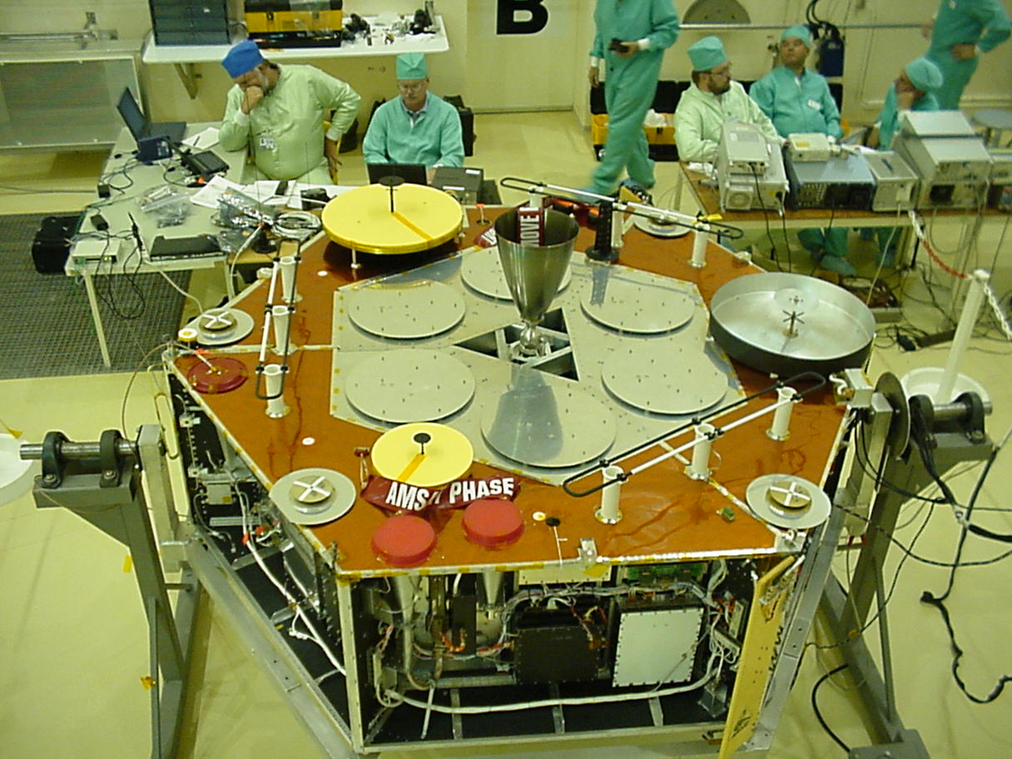

Figure 1 The P3d satellite undergoing final testing at the Arian launch site in Kourou. Shown is the antenna side of the satellite with two of the equipment bays visible. RUDAK is in the bay on the far side. Some of the GPS patch antennas may be seen around the edges of this surface. The two SCOPE cameras are on the far side behind and to the right of the engine bell.

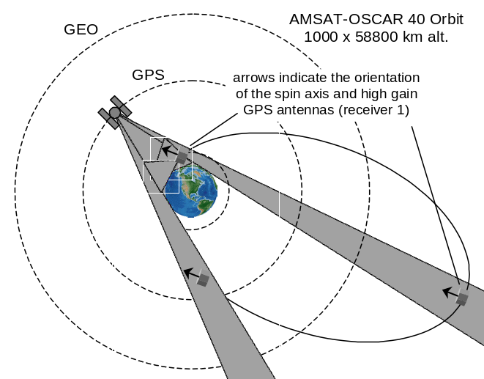
Figure 2 The AO-40 orbit relative to the earth, GPS constellation altitude, and the GEO belt. Roughly to scale.

The RUDAK (Regenerativer Umsetzer fur Digital Amateurfunk Kommunikation) is an acronym in German meaning roughly digital regenerator of radio signals. The idea of a digital communications module with DSP units programmable in space on an Amateur satellite originated with Peter Gulzow about 12 years ago. That concept evolved into the very complex and capable module flown in AO-40.

To date RUDAK has not been made available for Amateurs as a store and forward digital BBS or as a digital repeater. Operations have focused on continued testing and exercise of the experiments. Operation of the GPS and CEDEX radiation experiments has progressed beyond testing to operation and data collection. The temperature nodes were found operational and some data has been gathered. The SCOPE cameras have been used to take some interesting pictures and software work to make their operations easier and faster continues. The Monitor unit has not yet been tested.

In this paper we first describe the hardware of the RUDAK unit and the software that runs in it. We then describe each experiment RUDAK controls and discuss operations to date. In the section on the operation of each experiment we have included some results, however the detailed results and data analysis are deferred to the principal investigators. We conclude with a summary including plans for the future. Acknowledgements, a contact list and notes appear at the end.

RUDAK Hardware Description

The RUDAK hardware is designed to provide flexible communications links for the experiments it supports. It is not designed to be a spacecraft control computer, so does not provide complete loop load management. Indeed, RUDAK as implemented on the AO-40 spacecraft lacks the ability to turn its experiments on or off.

Since the focus of this paper is experiment support, the communications facilities of RUDAK will be briefly presented, then the specific design decisions made for experiment support will be described.

RUDAK System Overview

RUDAK consists of a pair of V53-based (x86 compatible) CPUs. Each CPU has 16 megabytes of Error Detecting and Correcting (EDAC) memory. The 16 megabytes is what is visible to the processor - it is composed of 24 megabytes of physical memory. Memory is organized to be byte addressable and accessible, with single-bit-per-byte error correction. The memory system is 16 bits wide.

The main mission of RUDAK is communications. Therefore, each processor has five (5) dual channel multi-protocol serial communications controllers (SCC) supported by 16 channels of DMA. Associated with each processor there are four (4) DSP-based modulators and four (4) DSP-based demodulators, two (2) hardware-based 9600 bit/sec FSK modems, and one (1) 153.6 kilobit/sec PSK modem.

There are multiple experiments depending on RUDAK for data and program information. RUDAK’s two CPUs have a high-speed parallel FIFO interface to enable them to share data quickly. Each CPU also monitors the state of the other, so if one fails and loses power, for example, the other can run all the experiments.

Experiments Supported

In addition to its basic analog communications payloads, AO-40 has a radiation monitor (CEDEX), numerous temperature sensors on a distributed network (dubbed Smartnodes on the CAN-LAN), a pair of GPS receivers with multiple antennas for attitude determination (Trimble units, modified TANS-Vector), an HF scanning receiver (MONITOR) and a pair of color CCD cameras (SCOPE).

Experiment Power Control

The AO-40 spacecraft contains many varied payloads. The primary spacecraft computer, called the Integrated Housekeeping Unit (IHU) is tasked with managing the overall spacecraft. Drawing on a long heritage of successful space operations, it is an updated version of a design first launched in 1980. It is based on the Sandia rad-hard version of the venerable RCA CDP-1802 COSMAC processor. It runs a threaded interpretive language called IPS, which is very FORTH-like.

The IHU is very limited in its computation speed, and its data links with the spacecraft command stations run at only 400 bit/sec.

For these reasons, the IHU was not considered suitable for interacting with and running the various experiments mentioned above. However, the IHU is tasked with spacecraft safety and power management, so it directly asserts ON/OFF control on all experiments.

Since it is vital that RUDAK know which experiments are currently active, the IHU outbound telemetry link, which includes status frames telling the state of all payloads, is tapped and monitored by RUDAK, using specialized logic burned into FPGAs.

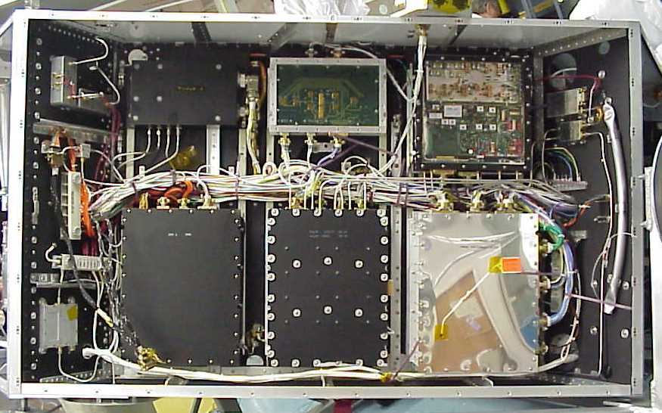
Figure 3 RUDAK is in the center lower module in this equipment bay on the perimeter of AO-40

Experiment Interfaces

CAN Bus

SCOPE, the HF scanner, the Smartnodes and CEDEX are connected on a CAN bus. CAN (Controller Area Network) was originally developed for the automotive industry to reliably transport sensor data and actuation commands with deterministic latencies. It has very small data payloads (8 bytes maximum). On AO-40, it operates at a signaling rate of 1 megabit/sec.

The Smartnodes, the HF scanner and CEDEX have relatively light data requirements, so the CAN bus works quite well for them.

There was considerable concern about the reliability of the CAN LAN in a high orbit, so great care was exercised in choosing the ICs for it. Further, since the Smartnodes would not have EDAC systems, they were designed to hold data for short periods of time to minimize corruption. Program information is stored on fusible link CMOS PROMs. The micro controller chosen was all-CMOS with no EEPROM cells used in its configuration. After nearly 18 months on orbit, they are performing well.

SCOPE Backup

SCOPE has a backup communications path in the form of an RS485 link. This is a 5V differential signaling system using standard asynchronous data format. Both SCOPEs listen to the outbound link from RUDAK, and the addressed camera responds on the paralleled inbound link. The drivers are tri-stated unless active.

Each SCOPE camera has two such ports, and each RUDAK CPU has one, so a failure of a RUDAK CPU along with the failure of the CAN LAN will still allow SCOPE to function.

GPS

The GPS receivers were not designed specifically for this mission, and lack both a CAN interface and tristate async drivers. Each receiver has a primary and a secondary port, however not all information can be passed over the secondary port. Further complicating the interface is the fact that only one serial port was available on the RUDAK processor board at the time GPS receivers were chosen. A method had to be developed to talk to a pair of GPS receivers on one port.

The solution was multi-faceted. First, differential RS422 signaling was used to maximize reliability at the physical layer. Each RUDAK CPU has a dedicated pair of RS422 receivers, one to the primary port of one of the GPS receivers, and the other to the secondary port of the other GPS receiver. Likewise, dual differential drivers are incorporated, connected to the same ports. These drivers are NOT tri-stated.

The RUDAK CPU selects which port it will drive, and which it will listen to, on its single available serial port.

There is a further problem in that the IHU had a single power control line available for both GPS receivers, but it makes sense to generally operate only one at a time due to antenna placements and the high power consumption of the receivers.

The solution was to make a special control board that allowed RUDAK to assert control in series with the IHU. Thus, the IHU can force both receivers OFF, but a receiver will only come ON if both the IHU and RUDAK command it. Of course this is further complicated by the fact that a RUDAK CPU might fail and with it the power control over the GPS receivers.

This part of the solution was implemented by using exclusive-or (XOR) gates for power commands, and monitoring the state of each GPS power switch. Each CPU has a control line to an input of each of the two XOR gates. If one CPU fails, the other CPU can still exercise positive power control over both GPS receivers.

The XOR gates are 4000-series CMOS, proven reliable in this orbit over many years on previous AMSAT missions. The schematic below details the power-switching scheme. Note that the XOR gate is powered as long as either RUDAK CPU has power. +10V is the primary power to the entire RUDAK chassis - if it fails, RUDAK is lost.

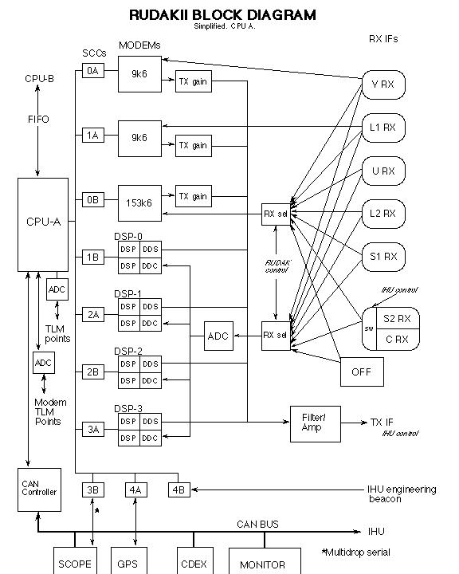

Figure 4 General block diagram of RUDAK and interconnected hardware including the experiments and communications equipment

Software

RUDAK uses the Spacecraft Operating System (SCOS) from BekTek, Inc. SCOS is a pre-emptive dispatch multi-tasking operating system optimized for use with the 80186 family of microprocessors. RUDAK is based on an NEC V53, object code compatible with the 80186. SCOS includes I/O drivers, data transfer protocols, and file systems designed for use in low earth orbit. SCOS has been flown on 28 spacecraft to date, with several more in various stages of construction.

General SCOS Discussion
SCOS is a child of the mid-1980’s. Its origins were as a software development platform for a multi-tasking I/O card for the IBM PC in 1986. The goals of that product were equally valid in the low cost spacecraft development world, allowing a “DOS” programmer to:

- Write applications without the need for in depth understanding of the hardware architecture.
- Write applications for a multi-tasking environment while paying as little attention to the multitasking environment as possible.
- Access serial I/O devices through SCOS streams and I/O drivers.
- Write applications in the C language.
- Include most standard C library functions in tasks.
The most important attributes of SCOS were that it :
- Had a very small footprint
- Allowed uploading of new tasks (programs) without affecting the rest of the running programs

SCOS was first posited at a fast food restaurant during a digital communications conference, when a software developer was seated between two groups of spacecraft computer designers. Both groups were looking for a small-footprint operating system that would allow fast development of sophisticated software. One group would launch the AMSAT microsats, the other UoSAT-3. It was agreed that a commercial package would be ported for both groups use, provided each used the architecture already supported by that package – 80186 CPU and Intel 8030 SCC. In only few weeks, both spacecraft groups had diverged, one to V40 and NEC 72001, the other to 80186 and an 8530 SCC. Each had a different mass memory access method. This led to an important design rule – keep any knowledge of spacecraft hardware particulars (expect for Vxx/80x86 differences) out of the operating system and firmly in the user domain.

This led directly to the kernel and “everything else” design. The kernel knows only about the CPU, primarily different hardware timer architecture. Everything else is a separate executable – a .EXE file in DOS parlance or a “task” in SCOS-speak. This led to a kernel that needed only minor changes from one hardware platform to the next, and it has therefore been very stable, running for more than five years in one case without a crash or reload.

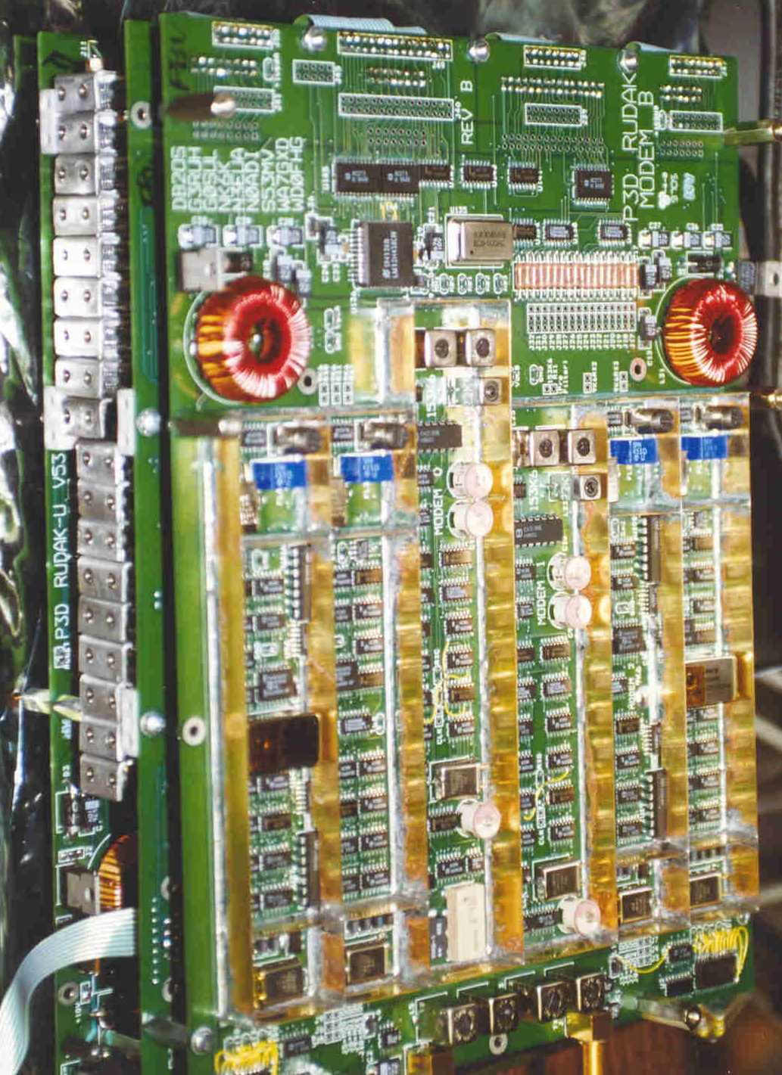

Figure 5 RUDAK board stack under test

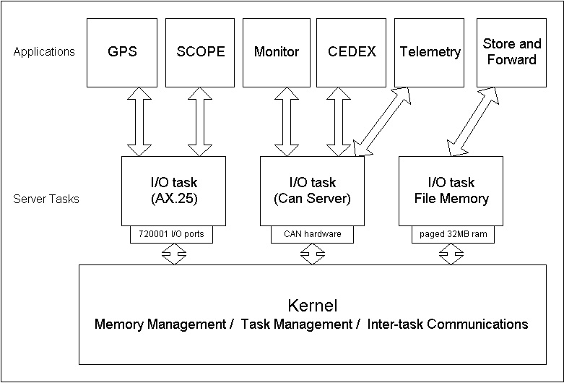
Figure 6 Each of the non-kernel tasks can be uploaded on the fly.

The kernel’s only job is to timeshare tasks, dole out memory on request, and provide a means where one task can send messages to another. On RUDAK, there are several tasks not shown in figure 6, including tasks for the CEDEX and MONITOR experiments, and a task to load software into the DSP modems.

In particular, I/O drivers were kept out of the kernel. In cases where a single software task owned a port, as in the case of the serial port to the GPS receivers, the I/O drier was linked directly with the user task. In the case of a shared facility, such as the CAN bus or the HDLC downlink ports, where several tasks need access, a server task is built. The server task uses the SCOS inter-task communications method called “streams” to exchange data with user tasks. The author of a server task typically provides an interface library that is linked to user tasks, and communicates to the server task via stream. The file system server task, the CAN server task, and the AX.25 protocol task all provide interface libraries in the model shown in figure 8.

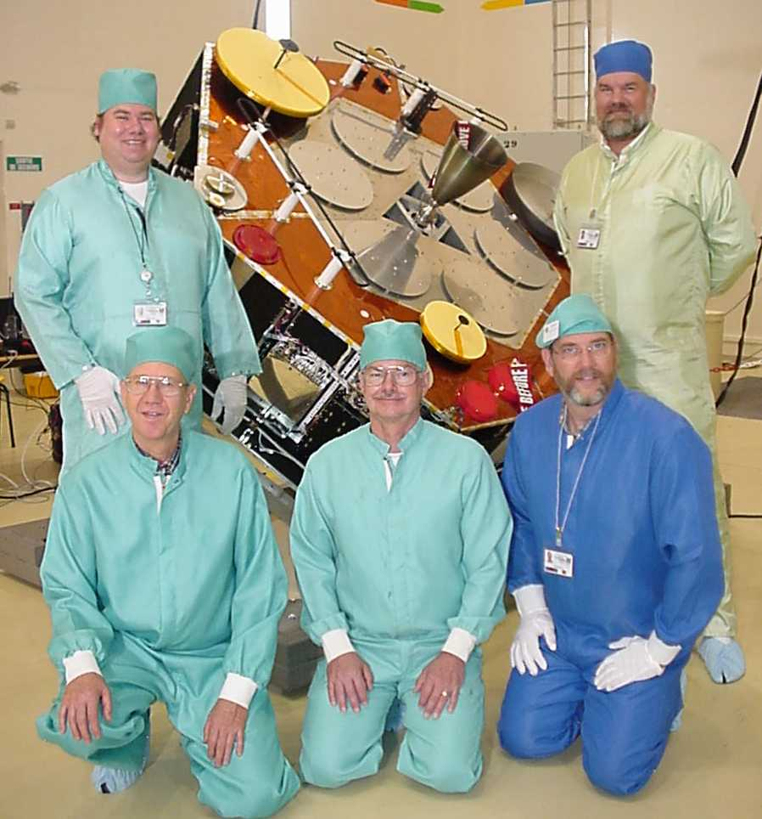

Figure 7 Part of the RUDAK team in Kourou: Left to right Peter Gulzow, Chuck Green, Jim White, Lyle Johnson, Bdale Garbee.

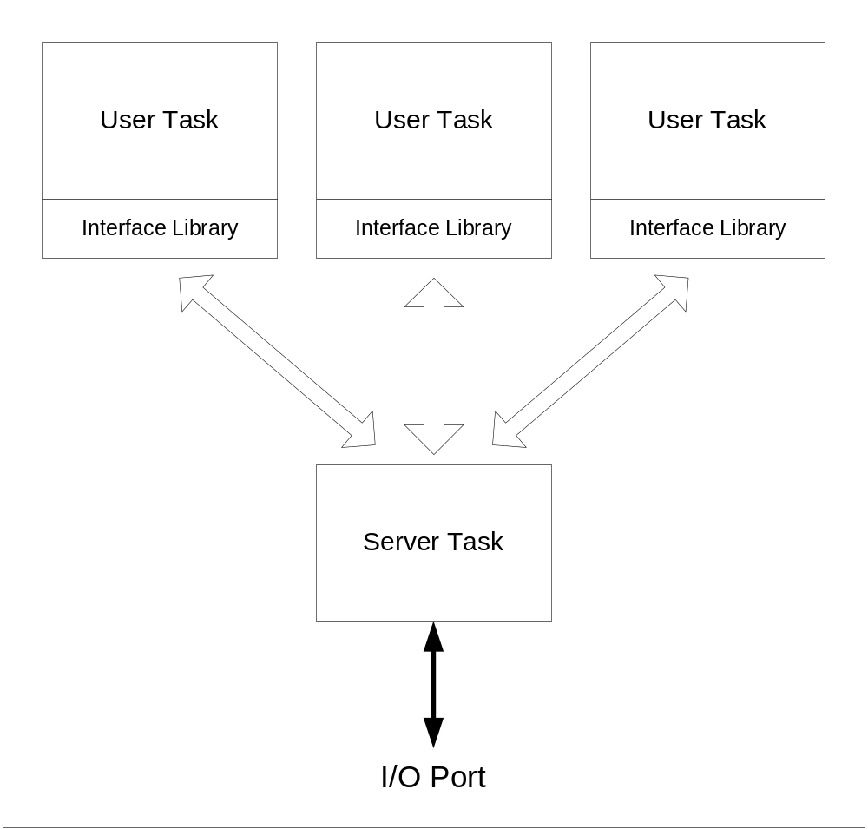
Figure 8 Server task model

All those tasks are a good thing – it leads to modular software design, and easily replaceable components. In RUDAK, each task has its own AX.25 call sign, and a ground station can individually access a particular task. There is no common message handling or downlink muxing point, each task talks to a peer or peers on the ground. This scheme has worked well for the types of spacecraft that use SCOS. They tend to have a large number of experiments run by different organizations in a company or completely different user organizations. While some interaction between groups is necessary, the less interaction required, the better.
One other hallmark of SCOS spacecraft is their tendency to rely on the file system as an intermediary between experiments and the ground. Small low cost spacecraft tend toward LEO, which limits the access time per orbit to 10-15 minutes, and a small number of passes per day. Complex experiments get their marching orders from “script” files that are uploaded in advance of need. Results, such as GPS data, radiation data, long duration telemetry, images, etc. are placed in files. A common file download facility is then used to recover the files and delete them once they are downloaded.
As the file system task and its attendant user interface offer fopen/fclose/fwrite/fwrite C library calls, large portions of the script and data storage elements of a task can be tested using desktop development tools in an environment familiar to the user.

Multitasking and task loading
For any but the most trivial of tasks, we view multitasking as a far better alternative to the “everything in a big loop” design. While highly time dependent real-time control tasks might not fit the model, most of the tasks undertaken by this class of spacecraft can accommodate a preemptive dispatch scheduler. Complex attitude control and orbit control, as demonstrated by SSTL’s Uo-12 spacecraft were performed on an SCOS platform.
SCOS tasks are event driven – they sleep in non-executing state until some event occurs, a message is received, a timer goes off, or an I/O operation is completed. Compute bound tasks are preempted on a 100 millisecond timer.
Tasks can be uploaded at any time. Tasks are compiled using a Microsoft 16 bit complier, and link into a relocatable .EXE image. A user task on the spacecraft handles the loading process in concert with a peer program on the ground. The ground program sends the size of the new task to the spacecraft loader, which gets memory from the kernel. The address of this memory is sent to the ground program, which then relocates the .EXE file to run at that location. The resulting binary is sent to the loader task, which copies the task into memory. Finally, the loader tasks signals the kernel to start the new task executing.
SSTL has written a facility that can take a .EXE file from the onboard file system, relocate it, and load it, all onboard. This is useful when a task needs to run only occasionally, or for faster reloading after a crash.
Many spacecraft in this class tend to be in a near constant state of software development. Some are training missions, others are on a short development cycle where the experiment software is written after launch. Others are hardware development missions where new algorithms are being tested. In keeping with the low cost nature of these missions, testing is done “in situ”, meaning in space. Due either to time constraints, or cost constraints, or both i.e., launching the only prototype, fresh software can sometimes crash. RUDAK, as with the other 16 bit 80x86 systems, does not have memory protection of one task from another. Misbehaving software can sometimes take down the entire system.
Almost all of the spacecraft that use SCOS have depended on a simple ROM-based bootloader. The SCOS kernel and a more complex loader are uploaded using the ROM bootloader. The other tasks are then loaded from the ground, or from onboard RAM. Again keeping costs low, file storage space is usually not hardware EDAC protected, it is instead protected with software block codes like RS. A file-based reload must occur before enough errors occur to swamp the ability of the block codes to correct the errors.

RUDAK Specifics
RUDAK and the AO-40 spacecraft was an ambitious (possible over ambitious) project. An amateur radio project differs from some commercial projects in the amount of testing that can be done, and the amount of software that can be developed. It is difficult to sustain interest over the several years (nearly 8 in the case of AO-40) that a project of this magnitude that take. AO-40 and RUDAK contain many operational modes and combinations of modes that were never tested, for example, interaction between the analog users and digital users in the same transponder. Software for the DSP modems, beyond simple hardware tests, has not been developed. RUDAK, which is two near identical independent modules (two V53s, two 32 MB ram disks, two sets of 8 HDLC I/O ports, two sets of 8 DSP processors) have outstripped our volunteer ability to produce the requisite application software. Next time (we promise each time) less is more.
Still, a substantial effort has gone into the project, with gratifying results.
CPU
The full complement of SCOS software and standard AX.25 and file transfer software developed for previous missions was ported to RUDAK, which was then used as the basis for other V53 projects for Canada’s MOST mission and several spacecraft from Spacequest.
Telemetry/Control
The standard AMSAT telemetry module, originally developed for AO-16 in 1989 was expanded and ported for use on RUDAK
CAN
Server software for the CAN bus, supporting applications for SCOPE, CEDEX, MONITOR, and various CAN-attached telemetry modules, has been used to gather data from all modules but MONITOR. MONITOR awaits the deployment of the solar panels.
GPS
Data has been gathered from both GPS receivers through the 9600 baud serial ports. The GPS data, including raw receiver data and algorithmic output, is regularly stored in the file system and downloaded. In addition, a pass through real-time mode has been used to directly connect a standard diagnostic software package on the ground to the space based GPS receiver. GPS data is encapsulated in AX.25 packets and sent to a TNC (HDLC to serial converter) on the ground.
SCOPE
Using both a serial interface and CAN, the SCOPE task communicates with a bootloader in the SCOPE camera to load software into the camera controller and store received images into the RUDAK file system for later download.

Ground Software
The initial software load is accomplished from the ground using a program specifically designed to interact with the ROM based boot loader in each RUDAK processor. Once the SCOS kernel and an initial housekeeping task have been loaded the kernel takes over memory management and another program on the ground is used with the smart loading in the housekeeping task to load the AX.25 stack and the full-up housekeeping task. That housekeeping task also includes the smart loader. At this point full telemetry and control of the RUDAK hardware is available. Generally the file system is loaded next because its capabilities are used by the tasks that run experiments. At this point individual tasks that work with each experiment may be loaded depending on the objectives. For example the SCOPE camera task may be loaded. SCOPE is an example of an experiment that must have software loaded into its computer from the ground. For SCOPE and similar experiments a binary image of the experiment software is uploaded to the file system. The SCOPE task is commanded to move that software into the camera processor and execute it. The SCOPE task is then commanded from the ground to set parameters in the camera, take pictures and move them to the file system, etc. Once a picture is in the file system it may be downloaded and post processed.
A single command program is in use on the ground to send all commands to all experiment’s tasks and the housekeeping task. That program also decodes and displays telemetry from the RUDAK module. In some cases a reduced function version of that command program has been provided to the experiment builders so they can control their experiment directly.

What’s next
A few refinements are in store for RUDAK software. These may include on board compression of data to compensate for a less than expected link margin and on board filtering of redundant GPS data. Further DSP modems may accommodate other data rates and be used to further investigate link margins. Because virtually all software is loaded from the ground great flexibility is possible. The housekeeping task has been modified several times since launch to add functions and fix minor problems. The software that runs in the SCOPE camera and the SCOPE task are presently being modified to compress the images in the camera and allow scheduling of photo sessions.

GPS Experiment

The GPS experiment on AO-40 was provided by the GPS group at the NASA Goddard Space Flight Center. It consists of two Trimble Tans Vector receivers, each with its own set of four antennas. The system is designed to provide experimental attitude determination as well as self generated Keplarian elements after the satellite is in three axis stable mode and the antenna side of the satellite is kept pointing at the earth. The GPS antennas on the side of the satellite containing the communications antennas have about 10dB of gain and a beam width designed to cover the earth and the GPS constellation when AO-40 is at or near apogee. They are connected to one of the receivers, referred to as the ‘A’ receiver. The other antenna set is on the opposite surface of the satellite and is connected to the ‘B’ receiver. These antennas have less gain and a broader beam width and are designed to receive signals when the satellite us near perigee and under the GPS constellation. The TANS Vector is capable of providing self generated Keplarian elements as well as attitude information in roll, pitch and yaw.

The objectives of the experiment are:
- Attempt to obtain a fix and generate Kep sets from each receiver when in the part of the orbit it was designed for.
- Measure and report on various GPS signal values from all parts of the orbit, but particularly from or above geosynchronous altitude.

Each receiver has two serial communication ports. One of these is connected through a switch to each of the RUDAK processors via a 72001 serial communications controller integrated circuit (SCC). Through that switching arrangement each RUDAK processor can control which GPS receiver it is talking to. To save I/O pins in the RUDAK unit, the switching is controlled using the hardware flow control lines from the SCC. With this arrangement each RUDAK processor can talk to each GPS receiver providing flexibility and redundancy at little cost. The communications links are 9600 bps serial and the proprietary binary Trimble protocol is used.

Operations

The receivers were initially turned on in September of 2001 and were found to be working. In late September an operational session was held during which the GSFC investigators talked the RUDAK command station through a number of tests that proved various functions were working properly. At this point the satellite was at about the altitude of the geo band. GPS signals were first detected during this session.

Logging of data commenced in late September and continued intermittently for about 30 days. The software running in RUDAK under SCOS logs data in 1 hour time blocks. During that period about 10,000 Mb of data was collected, downloaded, and provided to the experimenters. A good deal of data logged in RUDAK was not downloaded because the file size indicated no satellites had been head during that time period.

These data have been analyzed by the GPS group at GSFC and the full results have been reported elsewhere. A summary of the results is presented below.

Results

Although the GPS receiver was not initialized in any way, it regularly returned GPS observations from points all around the orbit. Raw signal to noise levels as high as 12 AMUs (Trimble Amplitude Measurement Units) or approximately 48 dB-Hz have been recorded at apogee, when the spacecraft was close to 60,000 km in altitude. On several occasions when the receiver was below the GPS constellation (below 20,000 km altitude), observations were reported for GPS satellites tracked through side lobe transmissions. Although the receiver has not returned any point solutions, there has been at least one occasion when four satellites were tracked simultaneously, and this short arc of data was used to compute point solutions after the fact. These results are encouraging, especially considering the spacecraft is currently in a spin-stabilized attitude mode that narrows the effective field of view of the receiving antennas and adversely affects GPS tracking. Already AO-40 has demonstrated the feasibility of recording GPS observations in HEO using an unaided receiver. Furthermore, it is providing important information about the characteristics of GPS signals received by a spacecraft in a HEO, which has long been of interest to many in the GPS community. Based on the data returned so far, the tracking performance is expected to improve when the spacecraft is transitioned to a three axis stabilized, nadir pointing attitude.

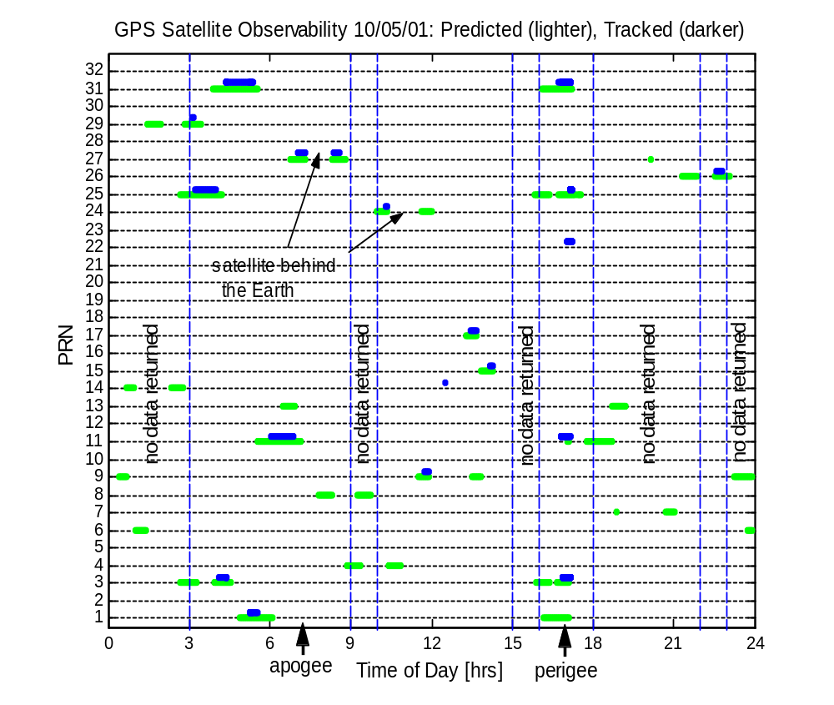
Figure 9 Comparison of predicted GPS visibility and actual satellites tracked on 5 October, 2001, showing typical tracking performance of receiver and data outages

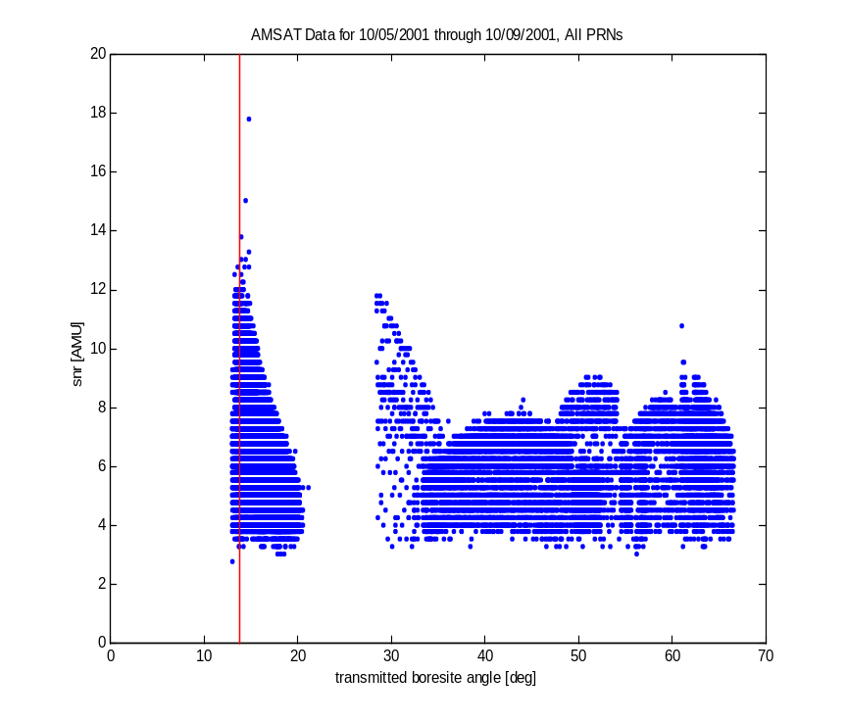

Figure 10 Raw GPS signal levels plotted versus transmitted boresight angle.

Issues

Initially the complex method for switching a single SCC serial channel between the receivers using the flow control lines proved time consuming to work out in software. However it has worked flawlessly since. In this case only one software task needed to know how to exercise the switch so no driver was necessary.

During development there was some concern the amount of data from these receivers at 9600 bps would be difficult for the RUDAK processor to handle along with other tasks. To this point that has not been a problem. We have run the SCOS kernel, the AX.25 protocol stack, the housekeeping task, the two tasks that make up the file system, and the GPS task continuously for several weeks without difficulty, while logging tens of megabytes of data to the file system. At one point we also ran the CEDEX experiment task, again without difficulty. We believe that parsing the tasks between the two RUDAK processors will allow full operation of all the experiments simultaneously in the future.

The RUDMON program on the ground along with the ability of the SCOS GPS task to pass raw TANS command and diagnostic data to and from the GPS receivers has proved particularly successful. Every time that software has been used commands and data have flowed between it and the GPS receivers flawlessly. To the user (in this case the RUDAK command station) that software gives the appearance of sitting at an ASCII terminal talking directly over a wired link to the TANS. This capability has made it possible to fully exercise all options of the TANS receivers and obtain instant diagnostic data. In fact it was during one such session that we first saw the apogee receiver hear a GPS signal and begin reporting its parameters.

A second data collection session was held between about 15 May and 15 June, 2002. During this period the apogee receiver was used to collect data nearly continuously. The perigee receiver was used during the final few days. Several additional MB of data were collected during this session. Analysis is ongoing.

SCOPE

SCOPE is an acronym for "Spacecraft Camera experiment for Observation of Planets and the Earth".

Objectives

The SCOPE experiment has the following three objectives.

- Taking full color pictures of the earth from high altitude orbit. Although there are several amateur satellites that have CCD cameras on board, most of them are monochrome and in low earth orbit. SCOPE is intended to show us the image of earth floating in space in real color just like astronauts saw from Apollo on their way to the moon.

- Supporting satellite's attitude control as an Earth sensor. The AO-40 satellite has capability of controlling its attitude with its 3 axis attitude control system that makes it possible for the satellite to look down at the earth at any desired angle. The SCOPE camera can serve as an alignment tool for this attitude determination system or may serve as a backup system.

- Evaluate SCOPE as a sensor for the flight guidance system. JAMSAT has a plan for an amateur satellite that will fly from the earth to another planet. Traveling from planet to planet requires a flight guidance sensor called a star tracker. The SCOPE camera is capable of seeing relatively bright stars and this capability may make it useful as a star tracker. SCOPE is also able of capturing the image of a destination planet. This capability of the SCOPE camera will be evaluated with the Phase-3D project.

Hardware

Two individual cameras Camera-A with a narrow angle lens and Camera-B with a wide angle lens are housed in a single module case .

The size of module case is 297(D) x 227(W) x 130.6(H) mm, the mass of the SCOPE module with its two cameras is 5.4 kg.

The electronics system consists of four sections, CCD head, CPU, Memory, A/D converter and Power Supply.

The cameras each use a 3 CCD head from a PAL standard camera used in the industrial image processing field. This CCD head consists of a dichroic mirror to separate the colors and three inter-line transfer CCDs for red, green and blue. Specification of the CCD is as follows:

Image Circle = 1/2 inch
Pixels=752(H) x 582(V)
Pixel Size=8.6(H) x 8.3(V) micron

These CCD heads are commercially available as spare parts for an industrial grade PAL standard camera and were modified to be driven directly from the CPU.

Commercial off the shelf zoom lenses which were designed for the CCD head were employed. The zoom is not adjusted in space but was set before launch to a specific focal length determined by a study for obscuration from a nearby object (V band antenna) on the spacecraft and the viewing angle from the final orbit. The two cameras have the same zoom lens with different zoom ratio settings to provide narrow and wide view angles.

The front clear aperture of the lens is 41.5 mm, and the planned field of view (FOV) of Camera A is 16 degrees and FOV of Camera B is 32 degrees . ND (Neutral Density) filters were be used to adjust for the relative brightness of the earth. Three filters each with x4, x8 and x8 factor are employed for both optics providing x256 factor number. Those ND filters and hood are modified commercial products.

The lubricant used in commercial lenses could evaporate causing fatal contamination. The flight lenses were taken apart, cleaned and reassembled using space grade lubricant. The focus is adjusted to a vacuum environment by taking the difference in refraction into account.

From 4000km these FOVs give following calculated resolution of objects on Earth.

Camera-A : 25km/pixel @ apogee, 4.6km/pixel @ perigee
Camera-B : 50km/pixel @ apogee, 9.2km/pixel @ perigee

To simplify circuitry, SCOPE uses a TMP68301 chip that is built around a 68000 CPU. This chip has 3 channels of UART, timer/counter, address decoder, wait generator, interrupt controller and 16 bit parallel I/O port all integrated in a single chip.

The CPU clock is selectable between 16 Mhz or 8 Mhz which helps reduce power consumption.

A initial program loader is stored in an AMSAT space proven HM-6617 fused link ROM. Each SCOPE camera has two sets of fuse link ROMs for redundancy.

The CPU section also contains an RS-485 async port and CAN bus (Control Area Network) interface to be used to communicate with other onboard modules for program loading, commanding and transferring picture data.

The memory section has 4 MB of HM628512 SRAM (Static RAM) in total. Within this 4 MB, 1 MB has EDAC (Error Detection And Correction) capability utilizing a IDT39C60.

The A/D converter section has three identical A/D converters, one each for the red, green and blue CCD. Each A/D converter has 8 bit resolution and with three of them 24 bit (16.7 million colors) will be reproduced.


Figure 11 A picture from the second session of SCOPE testing, December 15, 2001

There is a variable gain amplifier (x1 - x8) between each CCD and A/D converter to adjust the signal level.

Output from the A/D converters is stored in 3 MB of non-EDAC memory by the CPU. The A/D converter section also contains driver circuits and temperature monitor circuits for the CCD block.

The power supply section receives +10.6V from the satellite power bus and supplies +5V, +15V and -9V to other SCOPE sections. LM2577 switching power supply IC’s are configured as a flyback type power supply. To improve load regulation two similar power supplies are used, one supplies +5V only and the other supplies +15V and -9V. Power consumption is around 5W/camera.

A single bit switched by the IHU (AO-40 buss) turns on and off each camera.

SCOPE communicates with RUDAK via the CAN-bus or a RS-485 multi-drop serial link. SCOPE listens for boot load code as well as commands from the ground command station via RUDAK through the CAN-bus. Images captured by SCOPE are stored in RUDAK and then later forwarded down to ground stations.

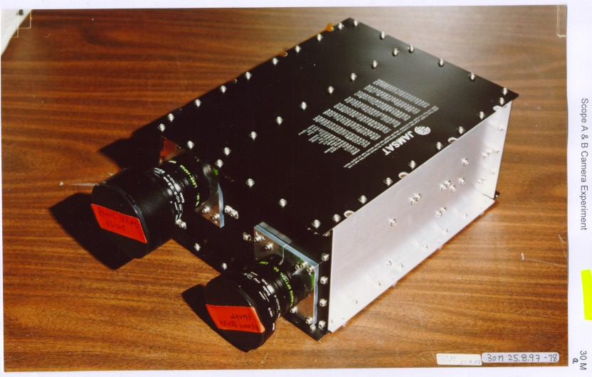Figure 12 The SCOPE camera module
An RS-485 multi-drop link serves as a backup to the CAN bus and links RUDAK and the two SCOPE cameras.

Software

Software that runs in the SCOPE CPU is first uploaded to the RUDAK file system. Once the SCOPE SCOS task is running a command is sent to that task which causes that binary file to be loaded into the camera CPU and executed. Further commands are then available to set the exposure, choose which camera to use, and take a picture. When a 'take picture' command is received by the SCOPE task it interacts with the SCOPE CPU to cause the image to be recorded and transferred to the RUDAK file system using a software defined file name partially based on time. Diagnostic messages are placed on the downlink to indicate progress and completion of the file move. Once the file is in the file system it is downloaded using the usual file transfer methods (the Pacsat Broadcast Protocol). Many pictures taken with both cameras can exist in the file system. Multiple versions of the SCOPE CPU code could be saved in the file system although this is not expected to be the normal operational mode. Once RUDAK is opened for general use any Amateur with a suitably equipped ground station can download these pictures.

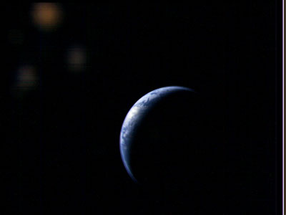
Figure 13 First picture taking by SCOPE wide angle camera, August 8, 2001

Operations

SCOPE was first exercised August 8, 2001. After a handful of pictures were taken at various exposures to characterize the operation of the cameras and lenses, the first published picture was taken using the wide angle camera. It showed a crescent earth floating in black space and was quite striking. Subsequently, on December 15, 2001, another set was taken with more of the earth illuminated. Both sets of pictures proved both cameras are working as expected.

Presently only the RUDAK command station is exercising SCOPE. However it is expected control will be transferred to the JAMSAT SCOPE team soon.

The first pictures were taken using the test and evaluation software and were time consuming to download. For each picture three full bit map images had to be downloaded, then byte swapped, merged, then compressed into .jpg format on the ground. Software to create color .jpg images in the camera CPU has been written and matching software to run in RUDAK is being created at the time of writing. This will make it possible to take a picture and download it in about 15 minutes or less as opposed to the 3 hours needed using the evaluation software.

The current images also suffer from blurring due to the spin of AO-40. The exposure time of the last pictures is .1 seconds so it should be possible to de-spin the raw images with post processing. If successful all the blurring at the edges should be eliminated. Of course when AO-40 moves into three axis stabilized mode this problem will go away.

Issues

The only difficulty encountered with SCOPE has been associated with moving large amounts of data across the CAN bus. CAN is not particularly efficient for moving large blocks of data. Software tricks to make it more efficient add complexity and software development time. These are however one time issues and will not effect ongoing operations.

It should be noted that successful implementation of the interface between RUDAK and SCOPE was facilitated by three face to face meetings of the respective software developers and the existence of two essentially identical SCOPE engineering units in their hands. Success would have been less likely and certainly more time consuming and costly without these units.

CEDEX
CEDEX is a re-housed version of the Cosmic-Ray Experiment (CRE) which already flies on the KITSAT-1 (KITSAT-OSCAR-23) and PoSAT-1 micro-satellites in low-Earth orbit. There are two sensors in the CEDEX experiment package.

Total Dose Experiment (TDE)

The TDE is based upon the AEA Technology (Harwell) design originally flown onboard UoSAT-3 (UoSAT-OSCAR-14) as part of the Cosmic-Ray Effects and Dosimetry (CREDO) payload, and is a direct derivative of the UoSAT-5 (UoSAT-OSCAR-17) variant. The purpose of the TDE is to measure the accumulated ionizing radiation dose inside the AO-40 spacecraft. This is done by a series of solid-state "RADFET" dosimeters (modified power MOSFETs) that have a thick (> 0.1 microns) gate-oxide to make them especially sensitive to ionizing radiation. Exposure to radiation causes the formation of trapped holes (positive charge) in the gate oxide, which in turn causes a gradual shift in the threshold voltage (Vth) with accumulated dose.

Cosmic Particle Experiment (CPE)

The purpose of the CPE is to characterize the AO-40 orbit radiation environment in terms of the observed particle Linear Energy Transfer (LET) spectrum inside the spacecraft. The data returned by the instrument are directly comparable to that obtained by similar instruments such as U.K.'s Cosmic-Ray Effects and Dosimetry (CREDO) and Cosmic-Ray Effects and Activation Monitor (CREAM) experiments which have flown on-board Concorde, the U.S. Space-Shuttle and UoSAT-3, and the Cosmic-Ray Experiment (CRE) flown on KITSAT-1 and PoSAT-1.
AO-40 represents a unique opportunity to characterize this high-eccentricity orbit. These data are also of great use in evaluating the radiation performance of the electronics used in the Phase-3D satellite.
Software
The CEDEX module runs from internal firmware that cannot be modified on orbit. In operation CEDEX attempts to connect to the CEDEX task running in the RUDAK module via the CAN bus and CAN server in RUDAK every few minutes. Once a session is established it sends packets containing CPE data to the CEDEX task every 10 minutes.
The RUDAK CEDEX task time-stamps the data and writes a record to a file in the file system. A new file is created each UTC day with a unique file name keyed to the date. Those files are downloaded by command stations as visibility opportunities occur. The files are emailed to the PI who post processes them.

Results

CEDEX was first activated in December 2001. On December 15 the first files were collected and downloaded. Over the next 12 days data were collected that included about nine orbits of the satellite. Some of those data are plotted in figures 14 and 15.

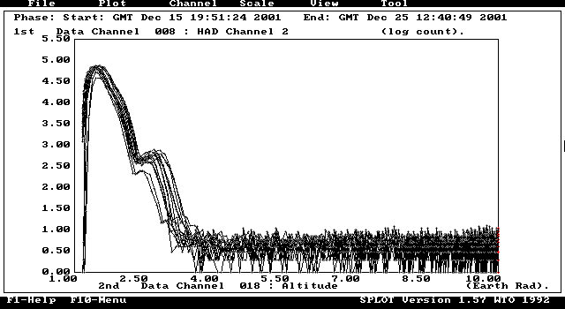

Figure 14 clearly shows the form of the inner Van Allen (proton) belt.

The horizontal scale is in geocentric Earth-radii R_{E} (1=Earth’s surface).

Because the magnetic field is not centered on the center of the Earth and the orbit precesses, there is a slight spread in count rates for each altitude.

The vertical axis plots the number of proton strikes in the detector over a 150 second integration period. The scale is logarithmic, - i.e. 5 = 100,000 counts, etc.

The peak proton flux is clearly shown at ~1.7 R_{E}, as is an unexpected second peak at ~ 3 R_{E}. This second belt is currently under investigation and may be related to recent solar flare activity – similar to the radiation belt created by the major flare of March 1991. A slight rise in galactic-cosmic ray flux is also discernable at high altitudes out to 10 R_{E}.

Additionally AO-40 has such a high apogee (about 10 earth radii), that it may prove possible to probe Earth’s bow-shock region, if the apogee becomes coincident with the mid-day meridian. If collection of these data is accomplished it will represent data may be correlated with data from the CLUSTER mission.

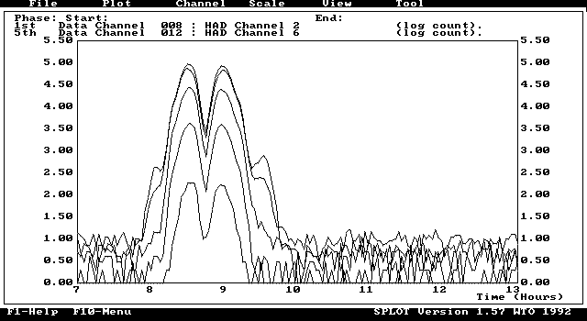

Figure 15 shows a “zoomed-in” view of the Van-Allen belt passage for the proton channels.

Channels 2 and 3 show the highest peaks (almost coincident in amplitude), with Channel 2 (and to some extent Channel 3) showing a curious second peak or “ring” around the main belt. This is very interesting indeed and needs further investigation. A double-peaked proton belt is not in the models!

Channels 4, 5 and 6 step down in particle flux more-or-less by a power law - as expected.

It took Phase-3D approximately 2 hours in total to traverse the belt (inward and outward bound).

Issues

CEDEX is the only experiment in AO-40 that when powered on autonomously wakes up and attempts to communicate with its managing task in RUDAK. This technique has proven quite successful in other satellites. Initial attempts to communicate with CEDEX indicated it was communicating with the CEDEX task but only time stamps were being logged to the file system. After the CEDEX experiment was powered off and back on proper communication was verified and data was logged. The reason for this initial difficulty is not clear at this point but is probably not related to the general idea of an experiment that autonomously attempts to communicate with a controlling task in a managing computer. Subsequent to that initial problem logging was successful until satellite power limitations required RUDAK and the experiments to be turned off for the sun-angle season. The next opportunity to work with CEDEX occurred in May and June, 2002. Through June 15, 2002, the symptom noted above again prevented logging data. Additionally the software in the RUDAK-B processor where the CEDEX task was being run crashed several times. At this writing it is believed this is a software problem and it is being investigated.

Future operation of the CEDEX payload in AO-40 is anticipated and is a priority for the mission. The software to communicate with CEDEX and log its data is neither complex nor large, and consumes little processing time. CEDEX has proven to be quite successful and is a strong candidate to be flown on future AMSAT missions that include a main processor and file system software.

MONITOR

The ionosphere MONITOR experiment is designed for passive sounding the space above the ionosphere in the HF band between 0.5 and 30 MHz. It measures the received signal strength with a frequency sweep or a repeat measurement on a selected frequency. The principal investigator for MONITOR is Peter Bakki from the University of Hungary.

MONITOR searches for the signals of terrestrial HF broadcasting sites that have passed through the ionosphere. Broadcasting stations work with high radiated power which in parts of the world is considered environment pollution. The objective of MONITOR is to better understand how this effects the ionosphere.

A program objective is to make simultaneous measurements of signal strength from the earth and from the space. This will allow calculations of how much of the signal is reflected and how much passes through the ionosphere.

Hardware

The MONITOR processor is a 68HC11 with attached fuse link PROM. The receiver consists of two mixers. The first IF is 45 MHz, the second is 455 kHz, both have a bandwidth of 7.5 kHz. A linear IF amplifier stage measures the received signal strength in 80 dB dynamic range. AM demodulation of the signal is also possible. The system can sweep in the whole frequency range with step sizes of 5 kHz and 9 kHz or repeat the measurements on one selected frequency.

Communications

Monitor communicates with RUDAK via the CAN bus using the CAN-SU protocol. It responds to 5 commands which control its scanning, dwell, and strength measurement functions. It returns signal strength and frequency data to RUDAK for storage in the file system and eventual download to the ground.

Software

Firmware in MONITOR resides in PROM and cannot be uploaded from the ground. A MONITOR task runs under SCOS to allow control of MONITOR. That task allows all MONITOR commands and data to be passed through to the ground for testing and checkout and also provides a way to poll MONITOR for data and store it in the file system.

Status

Use of MONITOR requires the deployment of the HF antenna which is stored behind the deployable solar panels. Those panels will only be deployed when three axis stabilization has been executed. As of this writing MONITOR has not yet been turned on or tested.

Issues

Debugging communications with MONITOR via the CAN bus was time consuming for both the MONITOR developer and the author of the SCOS MONITOR task. However at launch MONITOR was fully functional.

Conclusions

The RUDAK module has proven to be a very flexible and reliable experiment controller. While initially time consuming to implement its ability to communicate using multiple hardware interfaces and protocols has been well proven over the past year. In fact only a small portion of its capabilities have been exercised to date. The difficulties experienced by the AO-40 satellite have had much more effect on its communication transponders than on RUDAK or the associated experiments. In fact all hardware tested so far has operated without any apparent ill effects.

The ability to load tasks that control experiments individually and to kill them and load others has proven to be quite flexible and efficient.

In the future we expect to exercise the DSP units to implement other data rates and modulation formats. We also expect to continue to gather data from the CEDEX experiment. The GPS receivers, which were not expected to survive the radiation environment this long, will continue to be operated as time allows. As soon as the SCOPE camera software modifications are completed we expect to take another series of pictures. Some orbit planning has indicated a few rather interesting photo opportunities occasionally arise such as the nearly full moon next to the limb of the earth.

When three axis stabilization is achieved the antennas will be pointed at the earth all the time. This will allow longer periods of excellent communication links and should result in more time to operate and communicate with RUDAK. This in turn will allow more use of the experiments. Because of the longer windows and lower path loss when the satellite is closer to earth it may also become possible to open one of the RUDAK units to general use by Amateurs world wide. At that point we will very likely allow downloading of SCOPE pictures by individuals at their own ground stations. Scheduling software will also allow pictures to be taken when the satellite is out of view of the command stations. This opens up the possibility of some very interesting pictures of the earth from about 1000 km taken with the wide angle camera. The others experiments will benefit as well from longer RUDAK operational times. Additionally the lower path losses may make use of the high speed links (153k6 kb) possible by stations with minimal equipment.

While it is unlikely RUDAK will be reproduced exactly for use in future satellites the interconnection techniques and software drivers have already been designed into new satellite projects. The lessons learned are already being applied. It is hoped the RUDAK design information, both hardware and software, will prove useful to others.

Contact and information sources

A great deal of information about RUDAK may be found at www.amsat.org. RUDAK data is at amsat.org/amsat/sats/ao40/rudak/

Information about the current status of AO-40, along with many pictures and some additional RUDAK data may be found on the AMSAT-DL web page, www.amsat-dl.org. The current status is at www.amsat-dl.org/journal/adlj-p3d.htm. Background data is at www.amsat.org/amsat/sats/phase3d.html. Most information is available in German, English and Spanish

The SCOPE Project pages are on the JAMSAT web site. A good place to start is www.jamsat.or.jp/scope/index_e.html. Information is also available in Japanese and German.

Acknowledgements

The authors wish to thank the other members of the RUDAK team for information and ideas, the JAMSAT team for the hardware information on SCOPE, Dr. Craig Underwood for the hardware information on CEDEX, and Peter Baki for the information on MONITOR.

P3A was lost due to the failure of the launcher, P3B became AO-10 and still operates when sun angles are favorable, P3C became AO-13 which has reentered after several years of service.
qCF, from Quadron Service Corporation (www.quadron.com)
AO-16, which finally crashed when a section of memory went bad.
Pun intended.
Similar to UNIX pipes, though several tasks can exchange data through a single stream.
The file system task (MFILE) was originally written by Jeff Ward at Surrey Satellite Technology

