Cabell Garbee
MAMS – Torso, Sports

Lumbar Disc Pathology (Disc Herniation, Rupture)

A herniated disc is a rupture of the fibrocartilagenous material that surrounds the intervertebral disk in the spine. The discs are the pads between the vertebrae of the spine that allow for movement and cushioning of the vertebra. Disc herniation, rupture, protrusion, and extrusion are all terms that describe the injury with slight differences between the terms, but they all refer to a tear in the outer ring, which allows some of the inner core to escape and press upon the nerves of the spinal column. The most common location of ruptured discs are in the lumbar spine because they support the weight of the entire upper body with the L4-5 disc between the 4th and 5th lumbar bones and the L5-S1 disc between the 5th lumbar and 1st sacral bones being the most injured of all. Most clients can't recall a specific event that caused the ruptured disc, but when they can, it often involves lifting and twisting; which are activities that place severe stresses on the disc.
Factors associated with disk herniation include age, gender, and work environment, posture, hereditary conditions, and weight. The peak age for disk herniation occurrence is between 20–45 years. Studies have shown that men are more commonly affected than women for lumbar disk herniation by a 3:2 margin. Prolonged exposure to a bent-forward work posture is correlated with an increased incidence of disk herniation.

Causes of disc herniation are any direct, forceful, and vertical pressure on the lumbar disks that cause the disk to push its fluid contents into the vertebral body. Acute herniation may occur from lifting, twisting, or direct injury. Chronic herniation may occur from degenerative changes wherein the annulus of the disc becomes weakened over time allowing stretching or tearing of the annulus with episodes of intensifying symptoms as the disc nucleus is released.

Other conditions that cause back and leg pain can mimic a ruptured lumbar disc. Some of these conditions are: arthritis of the hip or knee area, pulled muscles in the back, pulled muscles in the leg, or other conditions irritate the spinal nerves.

Assessment of the condition will include a combination of history (client interview), physical examination, and imaging (Xray, MRI, CT scan, etc.) to make a diagnosis of herniated disc. Of these, a massage therapist may perform a client history and physical examination (assessment) as part of a session intake but would refer the client to a physician for imaging and other specialized tests for diagnosis.
History:
- how the pain began, how long it has been going on, and how severe it is.
- if an accident or fall preceded the pain.
- The state of the client's general health.
Physical examination:
- Observe the client for abnormal gait, which is suggestive of a loss of the normal rhythm, and have them walk on their toes to test the function of S1.
- Observe the client for abnormal posture, which is suggestive of splinting or guarding from pain.
- Test the client’s ability to dorsiflex the foot while sitting to test the L5 nerve.
- Palpation of the lumbar spine and lower back cannot be used to directly feel the herniation, but it should be done to rule out other causes of low back pain.
- A positive straight leg-raising test is indicative of nerve root involvement.
- This test is performed while the patient is lying supine with one leg either straight or flexed at the knee, with the sole of the foot flat on the table. The other leg is kept straight and lifted by the therapist.
- If pain occurs when the leg is lifted between 30-70 degrees from horizontal and travels down the leg until below the knee, the test is positive.
- Clients may exhibit decreased lumbar range of motion (ROM).

Since a definitive determination of the condition requires radiology and treatment involves the use of medications, clients exhibiting signs of disc herniation should be referred to a physician for treatment.

A herniated lumbar disc treated is most commonly treated in a conservative manner, with emphasis on pain relief and early mobilization. Four to six weeks of conservative treatment are common before a client can resume normal activities after an acute herniation. Herniated discs improve without surgery about 80% of the time.

Initial treatments for a herniated disc include the use of narcotic pain medicines, anti-inflammatory medicines, muscle relaxers, oral corticosteroids, and physical therapy. The drugs are used to reduce pain, strengthen the skeletal system, reduce pressure on the area, and reduce muscle spasming. Physical therapy is used to help loosen cramped muscles and ease pain both by physical manipulation and by the application of heat. In more server cases or for cases that do not improve, surgery to remove the protruding portion of the disc and relieve pressure on the nerves is performed.

Alternative treatments for herniated discs include acupuncture and massage. Acupuncture will involve inserting the needles along the pathway of the pain to move energy locally and relieve the pain. Massage may be used to provide short-term relief from a herniated disk by relieving muscle tension to reduce muscle spasming and by reducing pain by stimulating and closing the gate of pain messages (gate-theory) decreasing the intensity of the pain perceived by the brain.

Long term care involves lifestyle changes to decrease risk factors. Massage may be beneficial in reducing muscle tension and assisting in maintenance of postural alignment and pain management.

Figures:

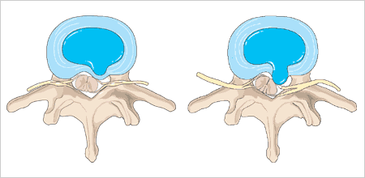
Bulging Herniated Disc

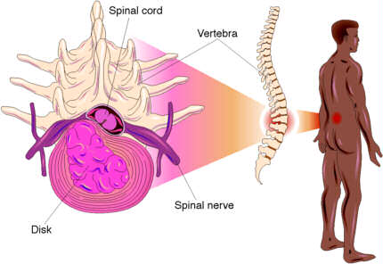

Herniated disc and spine

Reference:
http://www.backrack.co.uk/disc_index.shtml
http://www.steadman-hawkins.com/spine_lumbarDisc/symptoms.asp
http://www.chclibrary.org/micromed/00051060.html
http://www.emedicine.com/emerg/topic303.htm

