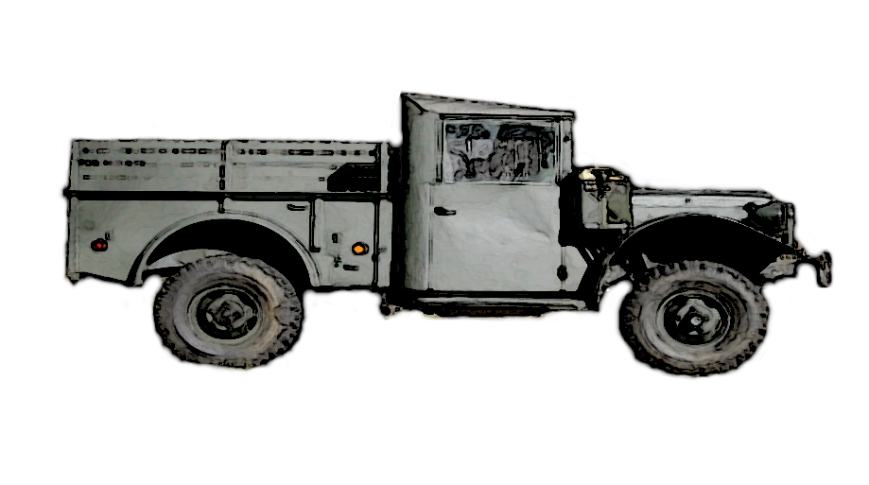  Dodge M37 Information and Parts  Cummins Repower/Tires/Bed Wood/Electrical  W. Cabell Garbee, II  www.garbee.net/~cabell 919-773-2143 | Dodge M37 Information and Parts  Cummins Repower/Tires/Bed Wood/Electrical  W. Cabell Garbee, II  www.garbee.net/~cabell 919-773-2143
Dodge M37 Information and Parts  Cummins Repower/Tires/Bed Wood/Electrical  W. Cabell Garbee, II  www.garbee.net/~cabell 919-773-2143 | Dodge M37 Information and Parts  Cummins Repower/Tires/Bed Wood/Electrical  W. Cabell Garbee, II  www.garbee.net/~cabell 919-773-2143
Dodge M37 Information and Parts  Cummins Repower/Tires/Bed Wood/Electrical  W. Cabell Garbee, II  www.garbee.net/~cabell 919-773-2143 | Dodge M37 Information and Parts  Cummins Repower/Tires/Bed Wood/Electrical  W. Cabell Garbee, II  www.garbee.net/~cabell 919-773-2143
Dodge M37 Information and Parts  Cummins Repower/Tires/Bed Wood/Electrical  W. Cabell Garbee, II  www.garbee.net/~cabell 919-773-2143 | Dodge M37 Information and Parts  Cummins Repower/Tires/Bed Wood/Electrical  W. Cabell Garbee, II  www.garbee.net/~cabell 919-773-2143
Dodge M37 Information and Parts  Cummins Repower/Tires/Bed Wood/Electrical  W. Cabell Garbee, II  www.garbee.net/~cabell 919-773-2143 | Dodge M37 Information and Parts  Cummins Repower/Tires/Bed Wood/Electrical  W. Cabell Garbee, II  www.garbee.net/~cabell 919-773-2143

