 | Tarheel Tracks
 | The official newsletter of the NCMVPA | winter 2002

President’s Message
It is Nov. 8th already; it is hard to believe that three months past since we organized, time flies when you are having fun. I am proud to inform you all that our membership is now 57 members strong. We had 4 official events that I am aware of, the two shows with the ATHS, the bungled one in Winston-Salem and the Cary Band Day Parade. There is no telling how many more by the time you read this. We have quite a few local Christmas parades coming up in the next few weeks and I hope to see more of you participating. Go to the calendar section of the web-site (www.ncmvpa.com) and register for the ones you can attend.
January is coming up pretty soon, and as we discussed back in the summer we are going to have real elections. Start thinking what position you would like to hold, we need President, Newsletter Editor, and Treasurer minimum. I would like to see a VP Events too, some who could initiate events and then hand it over to the event coordinator. I would also like to see the local members meeting more often for a social get together on a certain day each month. This way it will give everyone a chance to attend and meet their local members, and also will give other not so local members go to this or that meeting. We could meet for dinner during the week, or during the weekend.
The members roster will be ready soon. I am going to publish the following only, in order to preserve privacy. Name, City/State/Zip, and what vehicles the member owns. This way no one will be able to produce a mailing list or a phone list to sell, and one can get in touch with the member they are looking for through the list.
Well, I guess I said everything I had to say, have a happy holiday season.
Amnon

Tarheel Tracks Dates
I'm thinking that the Newsletter (which according to the MVPA must be published at least quarterly) should be published on the second week of the second month of each quarter. This puts a target publication date of the 14th of February, May, August, and November for future issues... Please try to send your contributions to the editor no later than a week before the publication deadline.
Cabell

Condolences
Joseph Tobul and his F4U Corsair crashed at the Columbia, SC air show during the Celebrate Freedom Events. Mr. Tobul was 68 and a former Marine who loved flying. The Corsair he was flying was a war bird that had seen action in the Korean war. The F4U still had patches were the flak damage to the wings sustained during the close air support missions over Korea was repaired. Every year during the air show in Columbia, he would lead a flight of War Birds to the
Veterans hospital. He would make passes, so the veterans who could not leave the hospital could see the planes. It was on this flight that he crashed. Taking care of his own. The Corsair lost power, and was put down in the trees to miss the houses in the area.
Semper Fidelis.
Frank USMC

NCMVPA
Amnon Nissan – President
Bill Stallings – Sec/Treasurer
Cabell Garbee – Newsletter Editor
www.ncmvpa.com
ATHS Letter
You might pass on to everyone that at our Executive Meeting last night for the Piedmont Carolina chapter of ATHS we discussed the new NC military club and how great it was to have you all at the Spencer Show.

Decisions made that effect the NCMVPA:

1) No more registration fees. Will still give out Dash Plaques to first 100 entries.

2) Give out more awards, have 3 classes of trucks for slow race, 1 award for each class, came up with about 7 other awards, still not judging!

3) Possibility of moving Spring show from Efland NC, to the Raleigh area, find a location that would be largest enough. Plan this for 2004, 2003 will most likely still be in Efland NC, first weekend in May 2003.

4) Design our own website and get up and running soon.

See you all in November!!
Nollie
[Ed note: The above letter was sent to us right after the September truck show at the North Carolina Transportation Museum. Several members of the NCMVPA attended with Tony Casey placing second in the slow race with his M715.]

Canvas Woes
A limb fell on my Deuce and tore the canvas top about 6 inches. I was trying to figure out how to sew it back together without taking it off. I was thinking me on a ladder outside, my wife inside, and we send a big needle back and forth. Well, that didn't work. I posted a message in the Mil-Veh email list and got a bunch of tips, but the best one came from a lister who mentioned Tear-Mender by VAL-A. It is an adhesive made for cloths. I called around and found out that TrueValue in Cary has it, $5.95 for a 6oz. bottle. I had to wait until the canvas was dry before applying it (with the rain we had lately that wasn't easy :-). I used a piece of a military canvas belt (the real thick stuff) to patch the tear. Let me tell you, I couldn't take it off if I try now. The stuff is something else, it comes off ones fingers just by rubbing together. I did it from the inside as directed, and you can hardly tell from the outside that it was repaired. So if you have a tear/hole in canvas, use it.
Amon

Greensboro ATHS Show
Four MV's showed up at the 3rd Annual Greensboro Antique Truck Historical Society show.

I was hoping for more MV's, but it was fun just the same. I didn't catch the total number of participants in the show, but I'd guess it was somewhere near 100 with four MV’s. There were some really interesting trucks, the oldest of which was a 1908. Others that caught my eye were a Diamond T pick-up truck and a "crew cab" fire truck.

They parked the M35 up on the hill in front of the show as an eye catcher. The rest of us were put in the back corner. Even so, there
was a great deal of interest from the attendees. I had burned the midnight oil getting my M725 ready to go. Its maiden voyage occurred about 16 hours prior to the show. I pulled it out of my shop, drove it around the block, and put it on a trailer to take it to the show. At the show, my 4 yr old daughter invited more than a few kids to get in the ambulance and play. Steve’s M35, my M725, and Cabell's M37 all participated in the slow race. I took home the last place plaque (slowest time) for light duty trucks with the M725.
Cabell might have secured the fastest time, as he was unable to get his t'case shifted into low range (oof). All in all, I think it was
worthy trip and I will plan to do it again next year. I hope some more of our membership will make the effort too.
Tony Casey
Veterans Day in columbia
A wonderfully entertaining tale of Joe’s adventures in Columbia, SC…

First: Last week ends parade and show. That may be the most fun I have ever had. The truck is a real conversation piece. I'm not a people person, but I have met lots of total stranger with the truck. I did feel a little out of place in the parade. We got separated from the rest of the MV's. We were in the right place, they got in ahead of us. It worked out OK because we fell in behind a group of Vietnam veterans that were walking in the parade and we looked like we were with them. I didn't serve in the military and I felt uncomfortable being in with these guys. They were real cool and seemed happy to have us behind them. I moved slow and as loud as possible. The kids seem to like loud stuff. After the parade we went to the air field for the week end. Met lots of people and learned a few thing. Met several people here from the military vehicles email list and several from the NCMVPA. For the next show I will bring a sidekick and a chair. I got tired of standing and not having someone to hang out with.

Next: Not all people will treat your stuff like it was theirs. Actually they will treat it like it's theirs, not yours. I was amazed at the number of children, with parents in tow, that would climb into my truck and start
pulling and twisting everything they could get their hands on. I can report nothing was damaged, but it is a deuce. They're not known to be fragile. Some one did sit or stand on one of the rods that hold the top off your head and bent it. It was easy to straiten. These kids climbed all over it. I
was concerned someone would bet hurt more than anything. Sure enough I watch one kid swing the gun around and whack another kid in the head with it. He was so happy it didn't phase him. I had to unhook the battery even though I have a key to keep it from cranking. I walked up to it Saturday
and could hear the horn solenoid clicking.

Finally: My thought provoking question of the day. Please, this is a "A" or "B" question. No essay questions here. Is it better to:

A. Let the children have a run on the truck and do what every they want as long as no one gets hurt or nothing is damaged or,

B. Keep them on the ground, look at it only, don't touch.

Of course with "A" they get to enjoy playing on an Army truck. They do enjoy pointing the gun at their friends and pretending to shoot them. They think this is cool. Their parents don't seem to mind.

With "B" they don't get to pretend to kill other people. They won't talk about the really cool truck with the gun on it they got to play with. They may not even remember the truck in a few weeks.

I wanted to let people, including children, touch the truck. All the pictures in the world can't take the place of seeing. And looking can't compare to touching. We like to sit in the drivers seat. We like to imagine we're someplace fascinating doing something incredible. It's called dreaming.

I was a little disturbed at how the children would grad the gun and point it at someone. That's not the kind of thing I wanted them to day dream about. I'm not sure if I will let anyone else get in the truck.

I leaned a few things from these experiences and I'm not sure I would care to share all of these lessons. If you don't learn every day you're not growing.

All in all I really enjoyed this past weekend.
Joe Trapp

More Veterans day in Columbia
It was a very good show marred by the fatal crash of a Corsair on Sunday. The Corsair was on its way to do a formation fly by at the Columbia VA hospital when it lost power and crashed. The pilot's son was
flying one of the other aircraft in the formation. The show went on as no one
knew for sure what the extent of the incident was although you could see the smoke in the distance. It was very sad to learn the outcome.

On a lighter note the military vehicle turn out was great. I trailered my Kubelwagen and Unimog to the event with my bother in law and we put up a German Afrika Korps diplay. We did some blank firing displays of various German weapons and had a great time. Another German reenactor was portraying a Luftwaffe pilot and on Saturday they conducted a mock interrogation of him as a downed enemy pilot. The tent was packed and everyone seemed to enjoy it. On Sunday we teamed up with the pilot and using the Kubelwagen we raided the US camp and captured the interrogator, took him prisoner, and proceeded out to the
blank firing field where he tryed to escape.
Unfortunately, he was shot down with blanks as he tried to escape. it was all in good fun. Other US reenactors from all eras were present and also put on demonstrations for the crowd

There were lots of US vehicles set up for display. There was a parade of vehicles scheduled for Friday, I did not get there in
time to participate in that. I hope they will continue on with this show next year and would recommend it.
Ben LeFever

Event Photographs
Photographs submitted by the membership to document these stories and other events may be found on the NCMPVA website.
Celebrate Freedom
The Celebrate Freedom Festival was held in
Columbia, South Carolina on November 8, 9, and 10. I arrived just prior to the gates
opening at 1pm and already people were lining up to go in.

There was lots of activity as vintage aircraft circled overhead prior to landing at the airstrip, and military vehicles of all descriptions were running about. After
being checked out by the large security force and paying a $5 "donation" for admission I entered the facility and was really impressed. There were approximately
50 to 75 military vehicles, everything from Cushman motor scooters and paratrooper
bicycles all the way up to an Abrams main battle tank courtesy of the USMC. My friend Tommy Hammill had his British Fox armoured car on display, which has just been restored and looked very nice in it's desert tan camo paint.

The aircraft were a big hit as well, with something for everyone, including B-17 and
B-24 bombers from the Collings Foundation which were open for touring, as well as numerous fighter aircraft, a Navy PBY flying boat, even an authentic Berlin Airlift transport aircraft. There were lots of rotor craft on display as well, with the majority of them being Vietnam-era Huey's.

All the vehicles I saw, whether aircraft or military vehicles, were all nicely restored and maintained and it was a real pleasure to see them. Also worthy of mention were the living history re-enactors who were set up at the far end of the airfield. There was a really impressive setup of US Army medical tents, including lots of re-enactors as “wounded." One thing that impressed me was a solitary Russian, who had an encampment set up as it would have
been during WW2. It was very educational to see all his equipment laid out, and he delighted in telling people all sorts of Russian Army facts. Did you know that the Russian Army did not issue their soldiers socks???? On the other hand, you should have seen the thick woolen boot inserts that were issued! Maybe that is why the Russians defeated the invading German Army during the war? I don't think the Germans had as good cold-weather equipment!

Overall, I think the show was very good, and I certainly plan on attending again next year, as well as joining the Celebrate Freedom Foundation. They have a website and the address is "www.CelebrateFreedomFoundation.org"

If anyone wants to experience a nice show next year, they would do well to check out
the Celebrate Freedom Festival.
James McNeely

Cary Band Day Parade
It was a great day for a parade. I drove the Deuce with My wife Cathy at my side. When we passed the "VIP stands" and the announcer mentioned "NC Military Vehicle Preservation Association" the whole block went crazy with whistles, clapping hands, thumbs up and yells. It was interesting to see the spectators just sitting there and watching the marching bands and "King & Queen" vehicles, but when the truck came about they all started clapping. Like I said, it was a good day for a parade.
Amnon

Veterans Day in cary
Several members of the NCMVPA met for lunch at the Golden Corral in Cary, North
Carolina on a slightly damp Veterans' Day. We had three military vehicles show up and participate in the event with several other members attending without vehicles. We had a great time talking to folks who came
by the restaurant. A big hit was Andy's Ferret.
Amnon
ATHS Show in Spencer
It started out as one of those days… I was late getting started and got to our rendezvous point in Cary (the Golden Coral) to find Amnon tapping his watch and wondering if I had decided to bail due to the forecast of rain… We headed out on US64 West and endured a light mist or drizzle until we got to Asheboro where we stopped for a breakfast biscuit. Between Asheboro and Spencer, we drove through rain hard enough to not only test the windshield wipers on my M37, but to demonstrate that leaving a few lower door seals off the truck had been a good idea since the water had a place to drain… I was seriously wondering if we would find anyone at the Transportation Museum when we got there, but I shouldn’t have worried. When we pulled up the hill from the highway to the truck display area, we already had a few military vehicles lined up for us to join. We ended up with eleven members attending with six vehicles from around the state and South Carolina. Almost all of the NCMVPA member trucks participated in the slow race (idea is to see who can go the slowest over marked distance) with Tony Casey placing second overall in his M715 5/4 ton. The rain played games with us all day alternating from a light mist to a heavy downpour, but we all had a great time.
Cabell

NCMVPA Membership
Unless we start to have expenses, there will be no dues for membership in the NCMVPA.

The NCMVPA is open to anyone who is interested in military vehicles, military history, and preserving our military history.

We encourage all of our members to join the International MVPA, but it is not a requirement of membership. Owning a military vehicle is also not a requirement for joining the NCMVPA.

Information may be found on the website.
Waxhaw Display
On November 9th Andy Hinson drove his 1942 Dodge ½ ton truck with matching Ben Hur trailer and Dan Pinkham drove his 1962 M37B1 Dodge truck to participate in the Veterans Day events in Waxhaw. Both were parked for a static display during the 30-minute ceremony to honor WWII vets.
About 50 people were in attendance. Information on the owner, history of
the M37 truck and the NCMVPA were attached to the M37. Many stopped and
asked questions and read the information. Dan got to mete one vet who had flown
Gooney birds to supply planes that actually flew the Hump during WWII.
Dan Pinkham

Veterans Day in Monroe
I drove my M37B1 to the old Court House at the county seat and parked it as a static display. About 300 were in attendance for the 90-minute program.

Information was posted on the M37B1 about myself, the truck and the NCMVPA for all to read and see. The ceremony included the posting of the major service flags including the POW/MIA flag, an address by Major General Mabry (Homeland Security Consultant Vice Director), a four aircraft squad F15 fly over by two different squads (one at the beginning and one towards the end of the ceremony), retirement of a WWII vets burial flag, several bag pipe numbers,
Air Force honor guard, Army honor guard, a bagpipe/bugle duet and a 21 gun salute.

Many Vietnam vets were in attendance and many admired the M37 but most didn’t say much.
Dan Pinkham
Charlotte Parade
In addition to driving the Press 1 Van in the President Bush motorcade on October 24 in
Charlotte, I had my M38 Jeep in the Veteran's Day Parade on November 9. My father who is a WWII Pacific Navy vet rode with me in the parade.
Joseph Turner

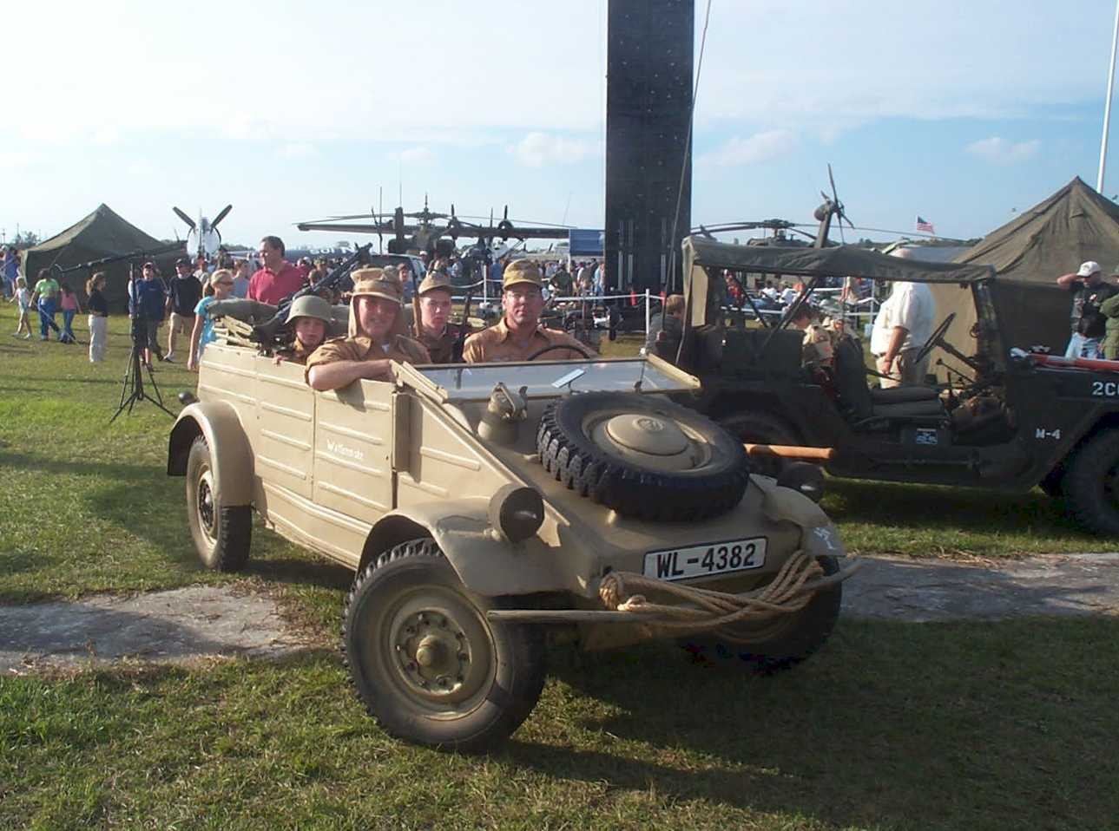

Ben and the boys go for a ride at Celebrate Freedom in Columbia

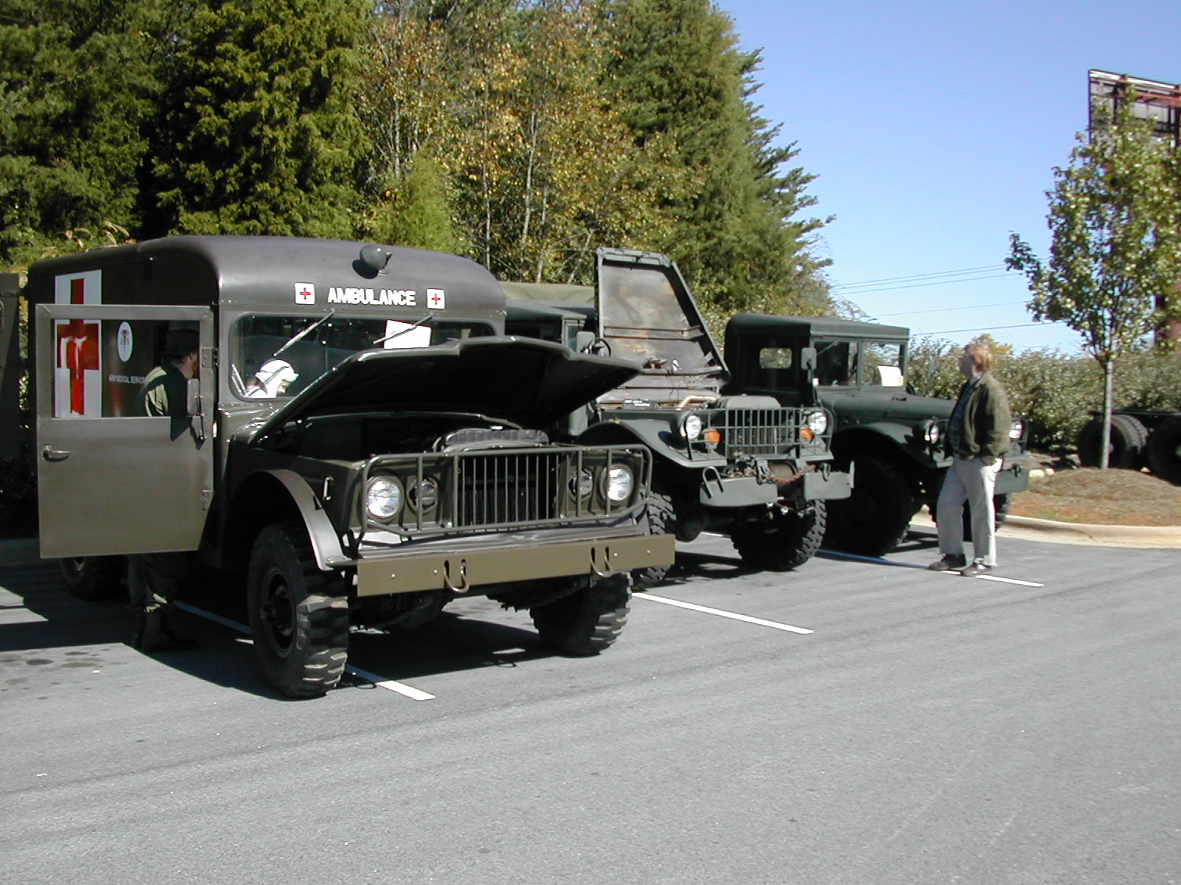

Portion of the NCMVPA lineup at the NAPA ATHS November show

