 | Tarheel Tracks
 | The official newsletter of the NCMVPA | Spring 2003

President’s Message
Hello everybody.
Digging out of the ice here, and can't wait for some warmer weather.
Well, we are up to 64 members now, and we have a new mean of communication now in the form of a message board on the web site and if you didn't register to use it, please do so right away. The message board should also serve as the membership roster we talked about in the past. It has a list of all the members, and each member can enter in their profile information they wish to share with others. A user can click on the "Memberlist" at the top of each page to list the members, and clicking on a member's name will open a window with the info they wish to share. I used the "Interests" field to list my vehicles for instance. Email is hidden so one can send it but not "harvest" email addresses. Click on your "Profile" (I know I asked you not to in the first message) and edit it to your liking. Anyway, I see no reason for an actual roster any more, any body disagree??

Let's see... I think we (my wife Cathy and I) did 4 Christmas parades last year. Cary, Fuquay, Apex, and Garner. Raleigh did not want any military vehicles in their parade because they didn't want to "worry" the spectators with the thought of war, their loss. The most attended parade was again the Apex one. Those Apex people really support their community. It is also held late in the evening when it is dark outside, which is different from all the rest. Fuquay was very busy too though. In the Cary parade this year I decided to stick flowers in the barrel of the .50 on the Deuce, and you should have seen the expressions on the adults faces as we drove through. Parents were pointing at it for the kids to notice, and there were a lot of thumbs up. Garner was nice too.

I would REALLY like to do more locally, more often. I am thinking of a weekly/monthly get together somewhere for lunch or supper so we can socialize more and expose our vehicles to the public. It should not be something that requires people to drive over an hour to get to, and it doesn't have to be held at the same place each time. I guess I need to start a new thread on the BB (Bulletin Board/message board).

Hope to see some of you at any of the upcoming events we are having (check the "Events" category on the message board)

And last, we need to hold elections. I said I would serve as president until January (2003 that is :-)

Amnon

Tarheel Tracks Dates
Tarheel Tracks is published on the second week of the second month of each quarter. This puts a target publication date of the 14th of February, May, August, and November for future issues... Please try to send your contributions to the editor no later than a week before the publication deadline.
Cabell

NCMVPA
Amnon Nissan – President
Bill Stallings – Sec/Treasurer
Cabell Garbee – Newsletter Editor
www.ncmvpa.com

Island Operations
A little while ago I took my deuce down to Charlestown SC as part of a work force. The deuce was the "support" vehicle. We loaded a gasoline power welder, air compressor with 1/2, 3/4 and 1" drive guns, and the extra fuel tank on the back. We took the truck, John Deere crawler, backhoe, Caterpillar skid steer and New Holland tractor over to an island with a barge. Then the barge brought the 40,000-pound tree grinder over and I hooked the old deuce to it and pulled it onto the island. For the two following days we cleared and ground 4 acres of trees and brush. The only thing the deuce had to do was dispense fuel. No equipment failure so the air compressor and welder was not used. Everything went perfect, except for the poor raccoon than apparently went though the grinder. We found his nose and whiskers in the mulch pile. At the end of the third day I backed the grinder back on the barge and we all headed back home. It was a three-hour drive, 40 degrees, and no heater. Still putting off installing the thing. I have a few pictures of the deuce sitting in the palm trees and on the barge. It has a "pacific theater" look to it. As usual the truck was a real conversation piece. Hope to see you guys on the 23rd. I'll check the web site to see if you guys are still meeting. By the way, I notice you and Amnon got you names in Army motors under the affiliated groups part, you old dogs.
Joe Trapp
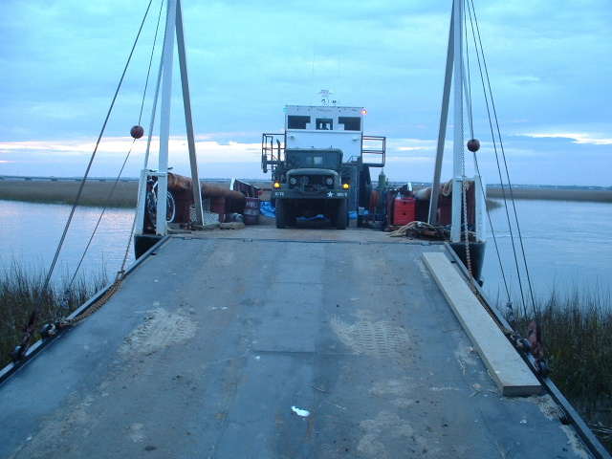

Coming off the barge.
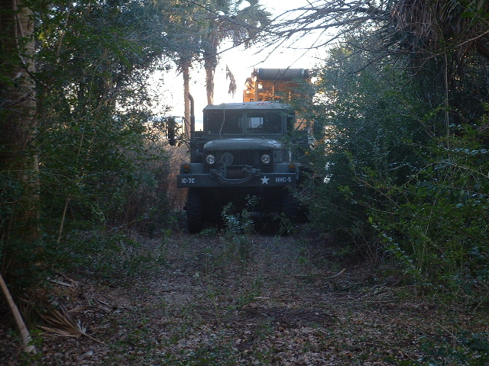

Sneaking through the woods.

For more photos of Joe’s M35 taken during its “island campaign” visit the NCMVPA website…

February Supper Meeting
A short while back one of the frequent posters to the MV Email forum sent out a note that he was going to be attending a conference in Durham and that he would be interested in meeting some fellow MV owners while in the area. Amnon and I both responded that we thought that a get together with Bruce one evening would be fun. After a little back and forth, we decided that the best thing would be to meet at our usual spot in Cary for supper on Sunday, February 23.

I rode over to the Sheraton in Durham and gave Bruce a ride to the restaurant at highway speeds in the Cummins M37. He said that he had never ridden in a M37 before...
He and I were both impressed with Amnon's Ferret, especially the work that he has done in accessorizing it since it was purchased.
Bruce has a M35, so he and Amnon also got to talk about common issues with their respective trucks and we all talked a bit about radios, dealers, rallies, and trucks…
Cabell
Churchville Rally
There is some discussion about getting together a convoy to the rally in Churchville this May. Churchville is the site of the big rally that used to be held nearby at the Aberdeen Proving Grounds.

The guys over on the BigElectric M37 forum are discussing the following: Convoy from Tidewater Virginia (Hampton/Newport News area) up to Richmond, VA, then up to Churchville. Have one person handle the registration or work with the event folks to ensure that we all get spaces next to each other (then we can watch each other's stuff and work together on meals, etc., if we want).
One of the guys who lives in the Richmond area has suggested that he coordinate the Richmond area meeting...
Bruce Kalin, the guy who is organizing/promoting the big convoy coming down from the Northern States met with Amnon and myself while attending a conference in Durham... He, Amnon, and I have been discussing the possibilities of the convoy heading up from the Confederate States joining his after they swing off the Interstate (I95?) and head toward Churchville. His thought is that we could hook up with them at the exit since our paths would be crossing at the point (they are coming down the road we would be heading up at this location...).
It seems like we could run routs from Norfolk, VA up to Richmond; from Raleigh and Kernersville (Winston/Salem/Greensboro) up to Oxford, NC then to Richmond, VA; and lines from further south could intersect the central and western NC crowd in Greensboro or Raleigh or could just run up I95 and meet up in Richmond with the rest for the ride up to the NOVA area to meet up with EricW's crowd from the valley of Virginia for the ride around DC to the contact with the Northern Convoy.
BruceK has also arranged for a block of hotel rooms for his convoy folks and says that the southern crowd can use them as well (or you can plan on camping out like EricW and I are -- join us...).
Bruce in Virginia has identified the Virginia Center Commons near Richmond as an obvious choice for a rendezvous spot for folks headed to the rally from points south. He is contacting the management to make sure it will fly, maybe even attract a little attention to the hobby. He is expecting a lot of MV owners here in the VMVA that might want to join forces as well with us for the ride up to Churchville
I know that the event is a ways off, but if we want this to work we need to put some coordinated thought to it.
Cabell
Upcoming Events/Meetings
Information on these events and others not yet announced at the time of publication may be found by going to the calendar and/or forum section of the NCMVPA website.

Churchville Rally, May 8-10 (see story)

Family Day, Greensboro June 8 (see story)

Spring Antique Truck Show in Efland NC hosted by the Piedmont Carolina Chapter ATHS. Once again we will meet at the event and park in the NCMVPA section...
Contact Nollie at 336-657-8083 - saddlemtn@skybest.com or Cabell at 919-733-7091 - cgarbee@ncmvpa.com

Standing Saturday Lunch Meeting
There will now be a standing lunch meeting at the Golden Coral in Cary. We will meet on the first Saturday of each month in the parking lot at 12:00 noon and then go inside for lunch and conversation. Contact Cabell or Amnon or check the website for info.
Family Day in Greensboro
Each year the Greensboro Naval Reserve has a Family Day where Reservists can bring their families out for a day of fun. This years Family Day will occur on Sunday, June 8, 2003. I have seen some of the military vehicles within your club at the NAPA and feel that other Reservists will find them as fascinating as I do. Please pass the word within your club that lunch (hamburgers, hotdogs, etc...) will be served at 11:30, so plan on eating.
The festivities will start around 10:00 and it usually lasts until about
4:00. Ample parking will be available at the Triad Armed Forces Reserve
Center, so we could reserve a few parking spaces for your clubs support
vehicles once we decide on how many is coming. Family Day is a way for the community and the Navy to show appreciation for the Reserves. Family Day also shows appreciation for the many Navy Reservists that are just now returning from active duty, after being recalled in 2001. We would be grateful for any participation that you could give us.
Thanks for your support,
Chief Petty Officer Hicks, USNR
I will coordinating our participation with Chief Hicks, contact me or watch the website for info, Cabell

Trailering Cautions
Forgot the chock: I thought that I would share an experience I had the other day.

I parked my F-350 truck, 5-ton trailer attached, on a slight, very slight
decline (down hill). I had unloaded the mini-excavator a few lots down the
street on level ground. It was the end of the day and most folks had left the area and I dropped my ramps, checked the park brake and started to SLOWLY pull the excavator on the trailer. I always load it slowly to give
the trailer and truck a break.

As I started up the ramps the truck and trailer moved slightly forward. This allowed the ramps to kick up and let the back of the trailer move down. This allowed the front of the trailer to move up, taking the rear axle of
the truck with it. Did I mention the park brakes are on the rear axle?

Much to my surprise I found myself and the equipment moving down the road. That's ok when I am driving, unacceptable at this point. I quickly swung the boom of the excavator around and slammed it into the ground. Everything stopped. I then chocked the truck and trailer wheels with a couple of bricks and finished loading. It didn't shake me too bad, but the dude walking by the trailer was a little excited.

After talking to my Father and brother, it turns out they had did the same thing years ago loading tractors. They had not shared this information with me earlier. That's why I am sharing it with everyone. I would
hate for anyone to ruin a perfectly good MV acquisition by taking an unexpected trip into the back of another vehicle when you pick it up.

Several folks have talked to me about putting blocks under the back of the
trailer. This is advice well given. If you don't have a way of keeping the back of the trailer from squatting down you are in real trouble. The trailer I was using, which I now use several days a week to haul the 8500-pound Kubota around, has legs on the ramps. These legs have always stayed put and kept the trailer up in the back.

As the trailer was pushing the truck down the hill it was able to move just a little without much resistance. As the legs where sitting on the pavement they remained stationary. As the trailer moved forward this allowed the ramps to start to fold up, as they folded up the back of the trailer moved down reducing traction on the truck. This could not have happened if the truck was parked level or on a slight incline. The hill changed a situation that normally works well.

Lessons I learned that I will use from now on:

1. Park on level ground.

2. Chock the front wheels of the truck or trailer wheels.

3. Make sure the back of the trailer is supported.

On a similar note, I learned a long time ago to use park brakes instead of the transition's "park". If you have a vehicle in park, or the park brake locks the axle (like on my Deuce) you only have to lose traction on one side
and the vehicle will role. I too keep a wheel chock in the old deuce. It's just too easy for a kid to release the park brake. I might have to crank the vehicle and pull up a little to get it out sometimes, but that's nothing compared to backing it off of another vehicle or neighbors shed (that happened to my Falcon once, it's not limited to MV's).

Think before you do anything, that increases my odds to 50/50.
Joe Trapp

After Joe sent the preceding story to the MV Email group, he got a few responses that I thought worthy of repeating… I don’t think that the original authors of the following two stories would mind us sharing them here in an effort to prevent further accidents…

Trailer Ball One: Several years ago after returning home from a long trip pulling loaded (loaded with Jeep) trailer behind my pickup; I pulled latch to release ball and jacked tongue up off ball. Much to my surprise the ball came out of hole in hitch on truck, the nut had come off and trailer was only staying on by tongue weight. I have never used a ball, since then that does not have stud on it that sticks through truck hitch. If I had been using the more poplar ones that have a bolt that sticks through and screws into ball I would have lost trailer and load - at a minimum - I hate to think what could have happened.
Everette

Trailer Ball Two: After I restored my 1945 MB, the first show I took it to was held at Fort Dix, NJ. I placed jack stands under the rear of my car trailer and drove the MB on. Dix is about a 2-1/2 hour drive from my place, going up bumpity-bump Rte. 206. After I arrived, I placed the jack stands and drove the MB off. No indication of a problem. After the show, I loaded the MB, put the stands in the toolbox and proceeded to leave. WHAM! Bump, bump and a jerk backward. I looked in the mirror and was shocked to see the trailer disconnected from the hitch. I had forgotten to lock the ball hitch when I hooked up the trailer. Serious case of dumb guy. Apparently, I had more tongue weight for the drive up than after I loaded for the drive home. Enough weight to prevent the trailer and my beloved MB from taking a ride on their own. DOUBLE CHECK THE BALL HITCH.
Joe Young

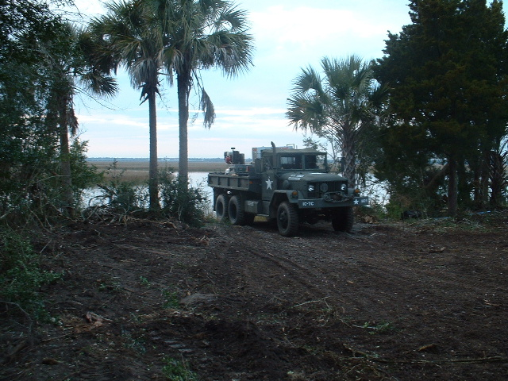

Another shot from Joe Trapp’s recent Island Campaign in the M35…
NCMVPA Website Forums
We have a new option called Forums. This is there to replace the mailing list we used before. The problem with the mailing list is that when a new member joined they knew nothing about what is going on, and there was no way to send past posts to them. With the Forums, the messages are always there, one can go as far back as the messages allow, and see what was, is, and is going to happen as far as club activity (it will not let you see what is going to happen with the stock market, no :-)

To sign up to the Web Based Forums, follow these directions.

Go to www.ncmvpa.com and click on "Forums". When the page comes up you will notice a "Register" option at the to of the page (not 'Login' but 'Register'). Click Register, go through the first page and click at the bottom. Type the username you want to be known on the forums, enter your email address, choose a password and type it in, then confirm it. Enter any of the details below if you wish, but I would like for you to use the 'Interests' field to list, in a very short form, the vehicles you have. This will allow other to know whom to get in touch with when they have a question about a similar vehicle.

In the Preferences section, change what you want if you are familiar with it, but make sure you do NOT show e-mail address. Click Submit at the bottom (you can always update this page through "Profile" in the menu at the top.

You will later on receive an email notifying you that your account has been activated. You can then go to the Forums and "Log In" with the user name and password you entered in the application.

A few pointers for usage. "New Topic" means exactly that, a new thread that that you are starting. If you want to reply to an existing message use the "Quote" icon in the upper right corner of the message you are replying to (each message has its own 'quote' icon). The original message will than be quoted at the top, enclosed with a [quote="xxxxxxx"] then the quote, then [/quote]. Try and keep the quoted text to a minimum. The quoted text is there just so that one doesn't reply with a "Yes" message to a message that asked two different questions for instance. So edit the quoted text to include the relevant text you are replying/writing about. Just make sure that the [quote="xxxxx"] and [/quote] stay intact. You then should type your reply below that section. NEVER MIND all the other icons and boxes on this screen!!!

You can "Preview" your reply so that you could correct any mistakes, then use the "Submit" button to send it. You can always return and "Edit" your own messages via the Edit icon at the top right corner of the message. You can also delete your own messages by using the [X] icon next to the Edit icon in that message.

Explore the Forums to list members (click on the member's username to list their details) and let me know if anything needs to be changed.
Amnon

Stories and other Submissions
I’m always looking for stories concerning your use of MV’s either at work or play. Send me a note and tell me about something you’ve done or witnessed recently or in the past and I’ll include it here for the rest of us to share and enjoy…

Email may be sent to me at cgarbee@ncvmpa.com or you can call me at 919-733-7091 during the day to get a USPS address for written submissions.
Thanks, Cabell

